Sustainable Energy Utility Advisory Board (SEUAB) Meeting
Tuesday, February 13, 2024
10:00 AM – 12:00 PM

Call to Order
Vice Chair Dr. Larry Martin called the meeting to order at 10:04 AM, February 13, 2024. Dr. Martin called a quorum of the Sustainable Energy Utility Advisory Board (SEUAB or Board) at 10:05 AM. This was a Microsoft Teams video conference call meeting.

Roll Call/Instructions
Roll call was taken at 10:03 AM and the following people were in attendance:

Board Members
Name | In Attendance? | FY 2024 Special Meetings  Attendance Record | FY 2024 Committee Meetings Attendance Record | FY 2024 Regular Meetings  Attendance Record
Pending - Board Chair (Mayor’s Designee) | N/A | N/A | N/A | N/A
Mansi Talwar (Councilmember Allen) | No | 1/1 | 1/3 | 3/5
Sandra Mattavous-Frye (or OPC proxy) | Yes | 1/1 | 3/3 | 4/5
Danielle Gurkin (PSC) | No | 0/1 | 0/3 | 2/5
Pending - (Electric Company) | N/A | N/A | N/A | N/A
Eric Jones (Building Management) | Yes | 0/1 | 3/3 | 5/5
Nina Dodge (Environment) | Yes | 1/1 | 1/3 | 5/5
Jamal Lewis (Low-Income Community) | Yes | 1/1 | 1/3 | 5/5
Jaleel Shujath (Economic Development) | Yes | 1/1 | 2/3 | 5/5
Sasha Srivastava (Renewable Energy) | Yes | 1/1 | 2/3 | 5/5
Giuls Kunkel (Building Construction) | Yes | 1/1 | 2/3 | 3/5
Dr. Larry Martin – Vice Chair (Council Chairperson Mendelson) | Yes | 1/1 | 2/3 | 5/5
Pending – (Gas Utility) | N/A | N/A | N/A | N/A

Other Attendees: Patti Boyd (DCSEU), Angela Johnson (DCSEU), Ben Burdick (DCSEU), Crystal McDonald (DCSEU), Jahmai Sharp (DCSEU), Tamara Christopher (DCSEU), James Clarke (DCSEU), Nikola Jovic (DCSEU), Philip Haddix (DCSEU), Solome Girme (DCSEU), Philana Owusu (DCSEU), Jennifer Johnston (DOEE), Dr. Lance Loncke (DOEE), Dave Epley (DOEE), Hussain Karim (DOEE), Dr. Yohannes Mariam (OPC), Kintéshia Scott (OPC), Adam Carlesco (OPC)

Approval of Agenda
- Vice Chair Dr. Larry Martin moved to approve the agenda and was seconded by Jaleel Shujath. All were in favor, and none were opposed.

Approval of January and February Minutes
- Vice Chair Dr. Larry Martin moved to approve the January and February meeting minutes and was seconded by Jaleel Shujath. All were in favor, none were opposed.

Contract Modifications
- Dr. Lance Loncke (DOEE) provided an overview of DCSEU’s contract modification which is currently under legal review:
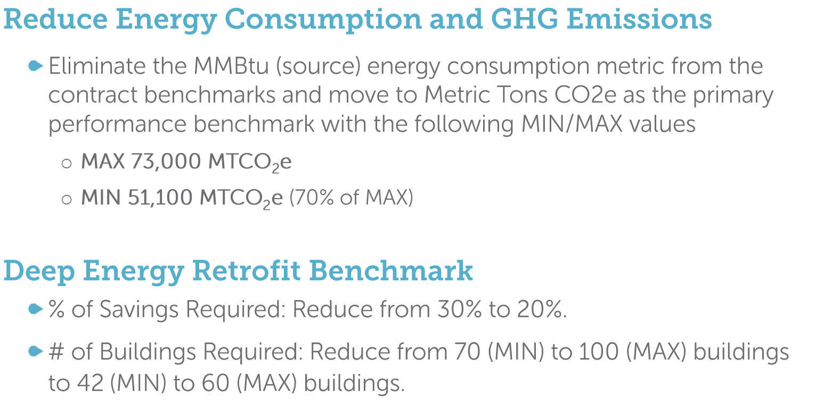

DCSEU FY24 Q1 Update
- Ben Burdick (DCSEU) presented on DCSEU’s FY24 Q1:
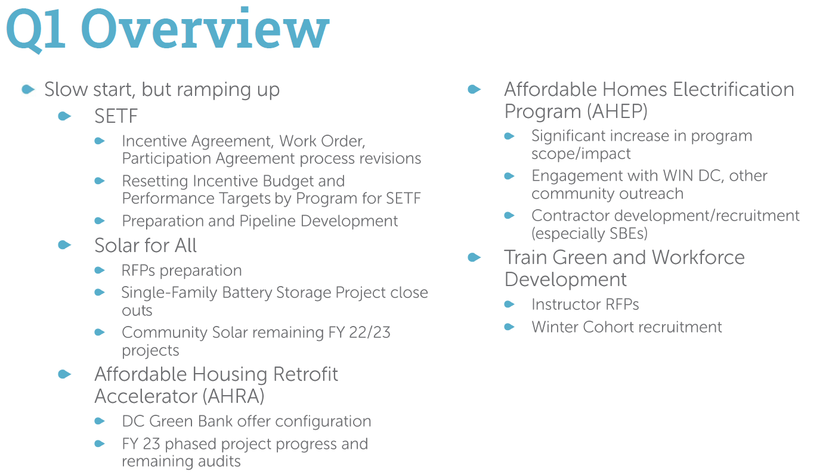
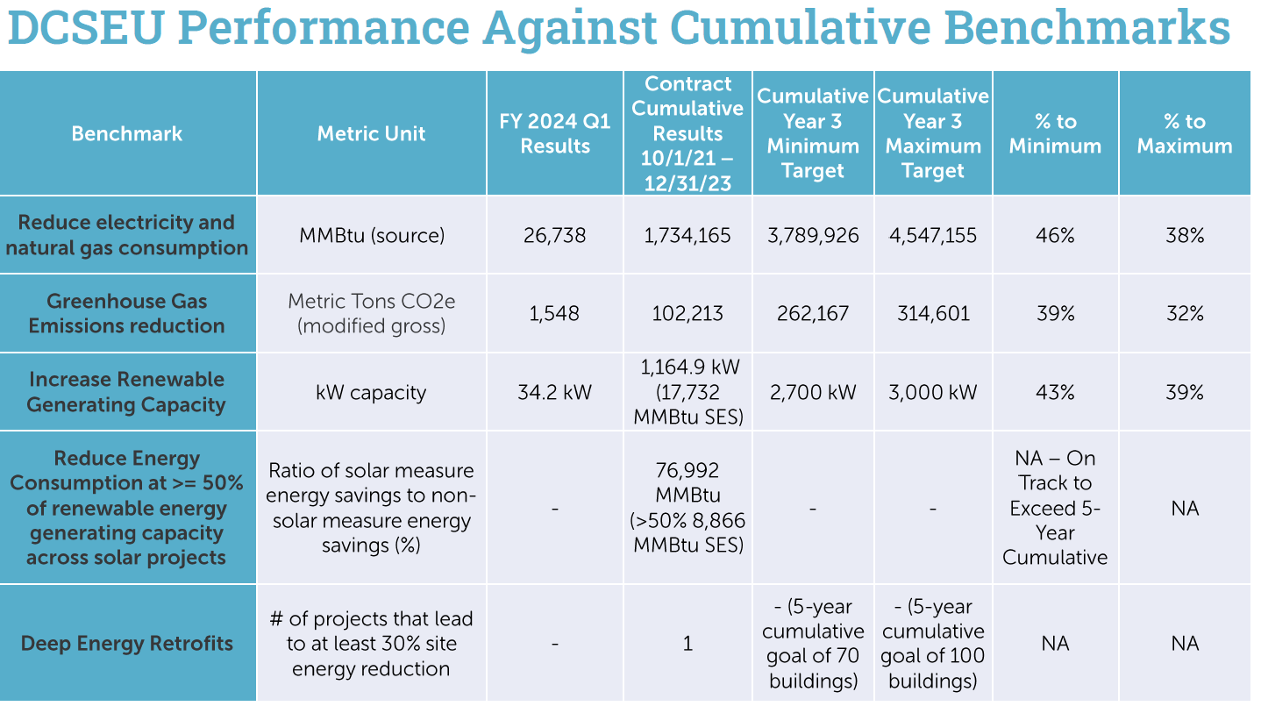

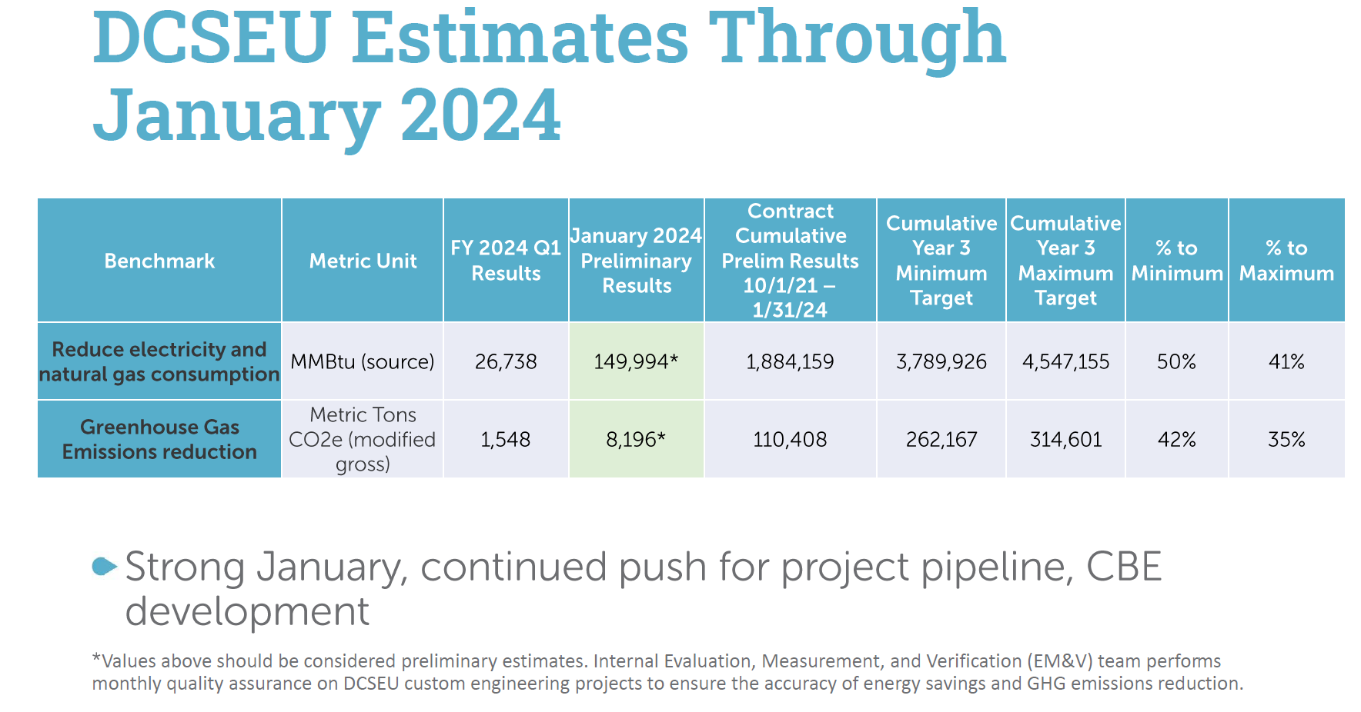
- Patti Boyd (DCSEU) presented on the renewable energy + energy efficiency benchmark:
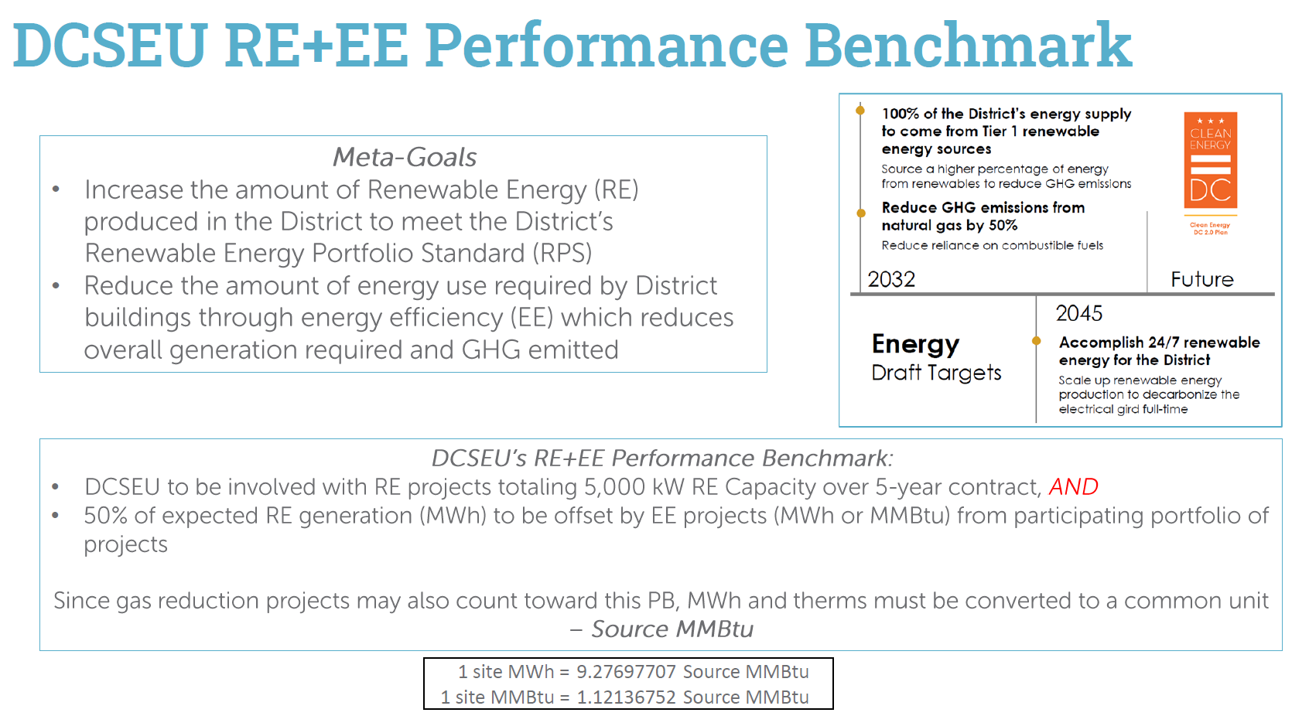
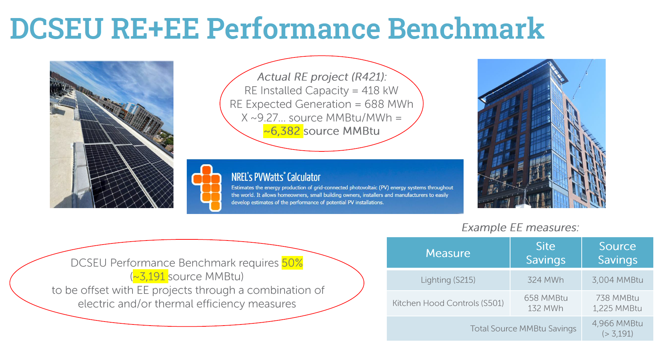
- Nina Dodge asked:
  - What is the difference between source and site savings?
- Patti Boyd (DCSEU) shared that source energy represents the total amount of raw fuel that is required to operate and site energy is the amount of heat and electricity consumed by a building (reflected in utility bills).
- Jamal Lewis asked:
  - Are the conversion factors based on the current grid mix or is it factoring in elements of the grid getting cleaner?
- Patti Boyd (DCSEU) shared that the conversion factors were based on the current grid mix and derived from a calculation methodology. Patti offered to share the methodology with Jamal.
- Nina Dodge thanked the DCSEU for presenting the information in a framework that was easily digestible and encouraged the DCSEU to continue sharing information in this form.

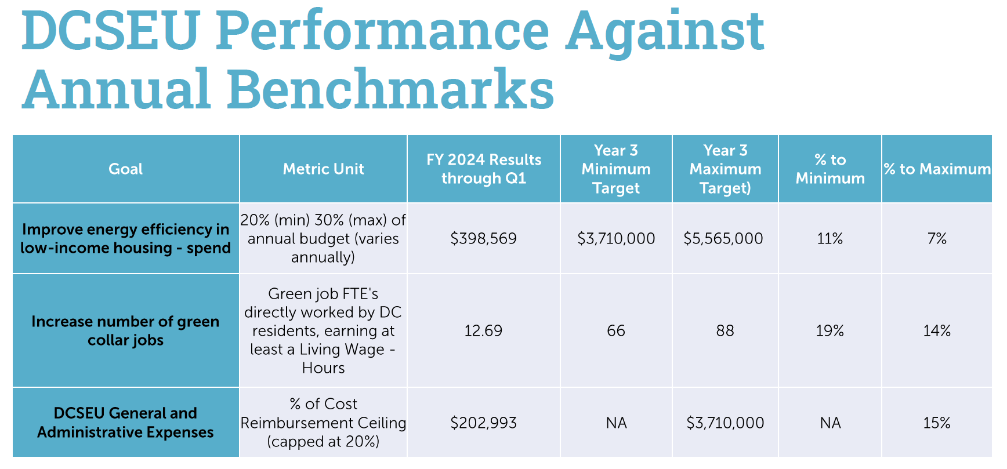

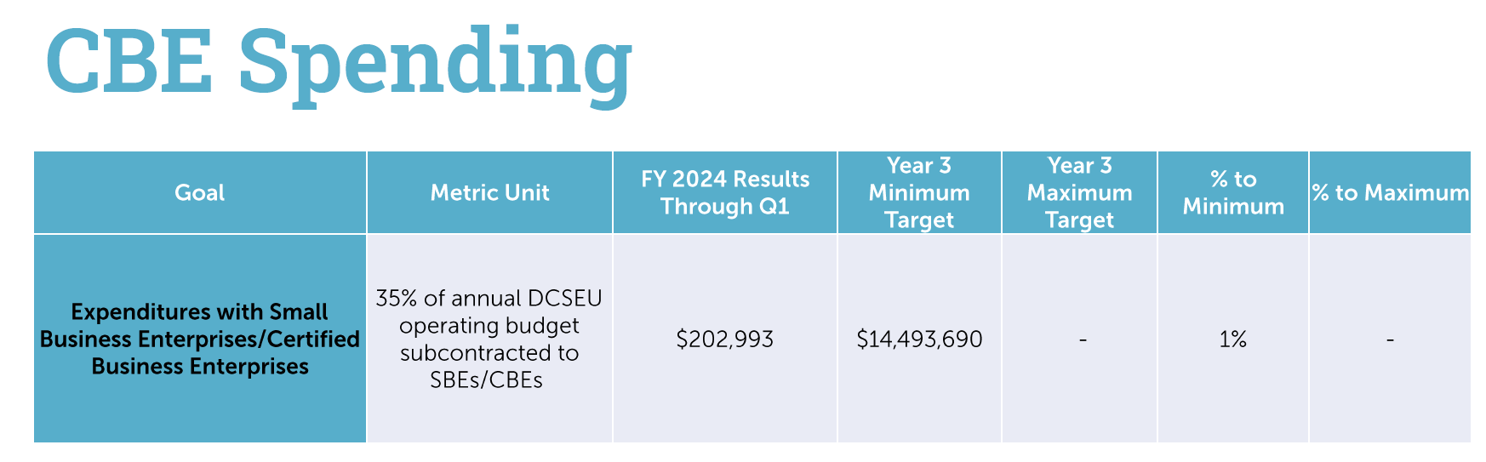

- Jamal Lewis inquired:
  - Does the DCSEU have any pathways to accelerate the CBE spending?
- Ben Burdick (DCSEU) shared a lot of DCSEU’s CBE spend is derived from direct installation work, so the DCSEU will not reach the higher numbers until the contractors begin their work.
Additional, the DCSEU of working with at least two contractors are in the process of becoming a CBE via DSLBD’s guidance.
- Solome Girma (DCSEU) presented the following slides:
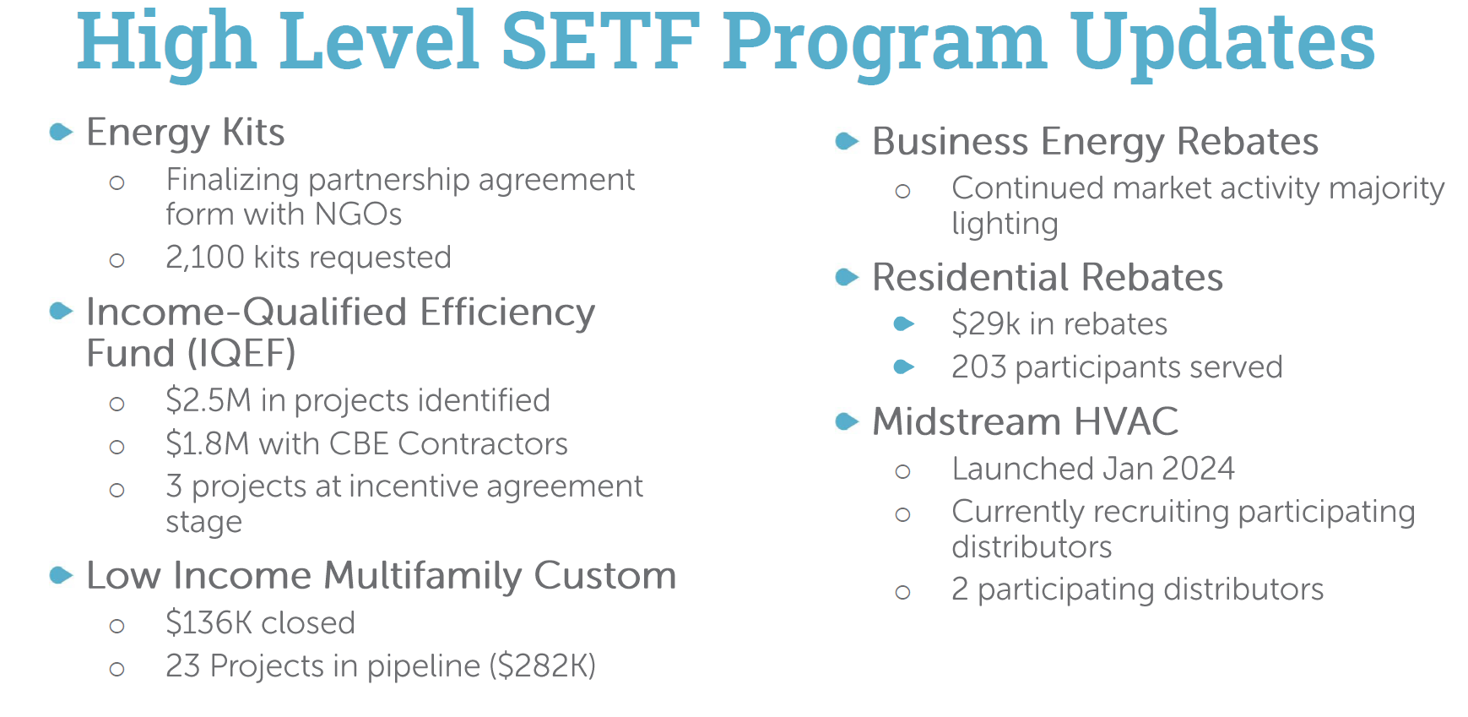
- Vice Chair Dr. Larry Martin asked if building energy management systems were included in the business energy rebate offerings?
- Solome Girma (DCSEU) shared that building energy management system projects come through DCSEU’s custom rebate program where engineers work with the building owner/operator to determine the savings.
- Giuls Kunkel mentioned that there are building owners and operators that are not aware of the rebates for lighting retrofits offered by the DCSEU.
- Solome Girma (DCSEU) mentioned that she would be interested in meeting with Giuls to understand how to reach more building owners.
- Nina Dodge asked:
  - Does the DCSEU measure the impact of the building controls that have been installed?
- Patti Boyd (DCSEU) mentioned that the DCSEU tracks energy performance for the buildings that participate in a pay for performance program. The DCSEU utilizes BEPS data to track progress.
- Nina Dodge highlighted that the DCSEU has an opportunity to take a leadership role in educating building managers on the benefits of optimizing building controls.
- Eric Jones mentioned that getting building owners and managers involved is a dollar and cents discussion. With the upcoming BEPS deadlines, a lot of property owners and managers are not going to take a risk if they do not see the benefit. Eric highlighted that outside of a rebate, explaining the long-term impact of being able to operate the buildings.
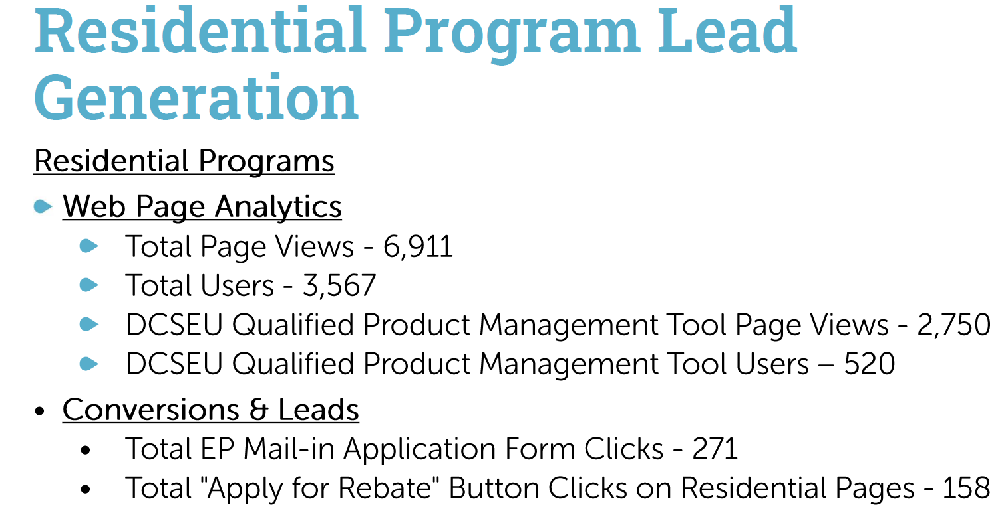
- Crystal McDonald (DCSEU) presented the following slides:
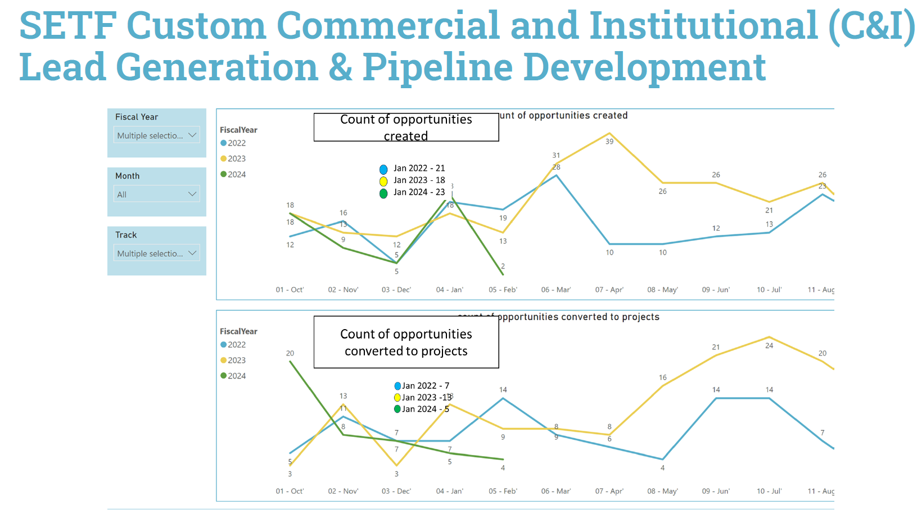
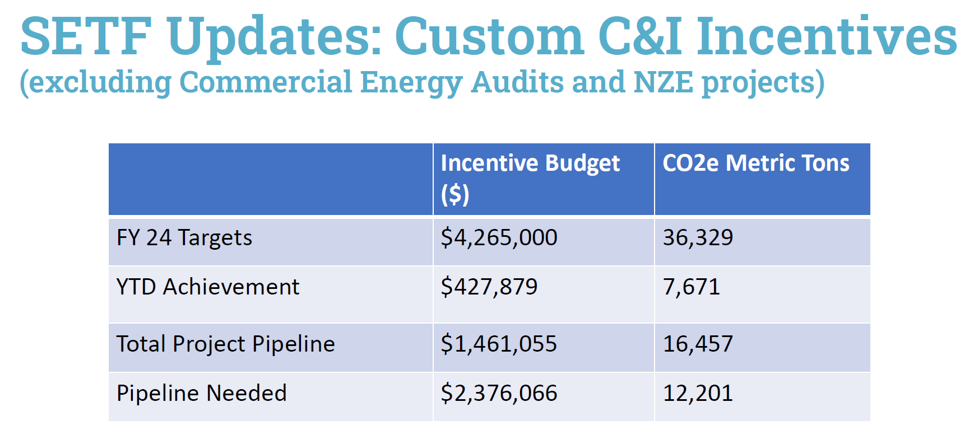

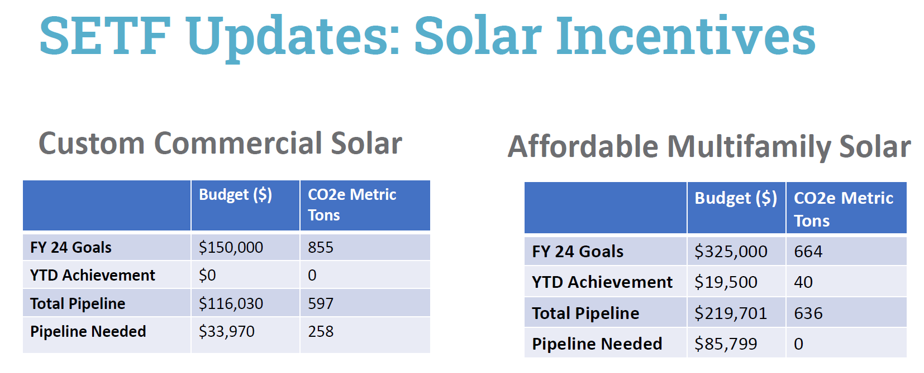

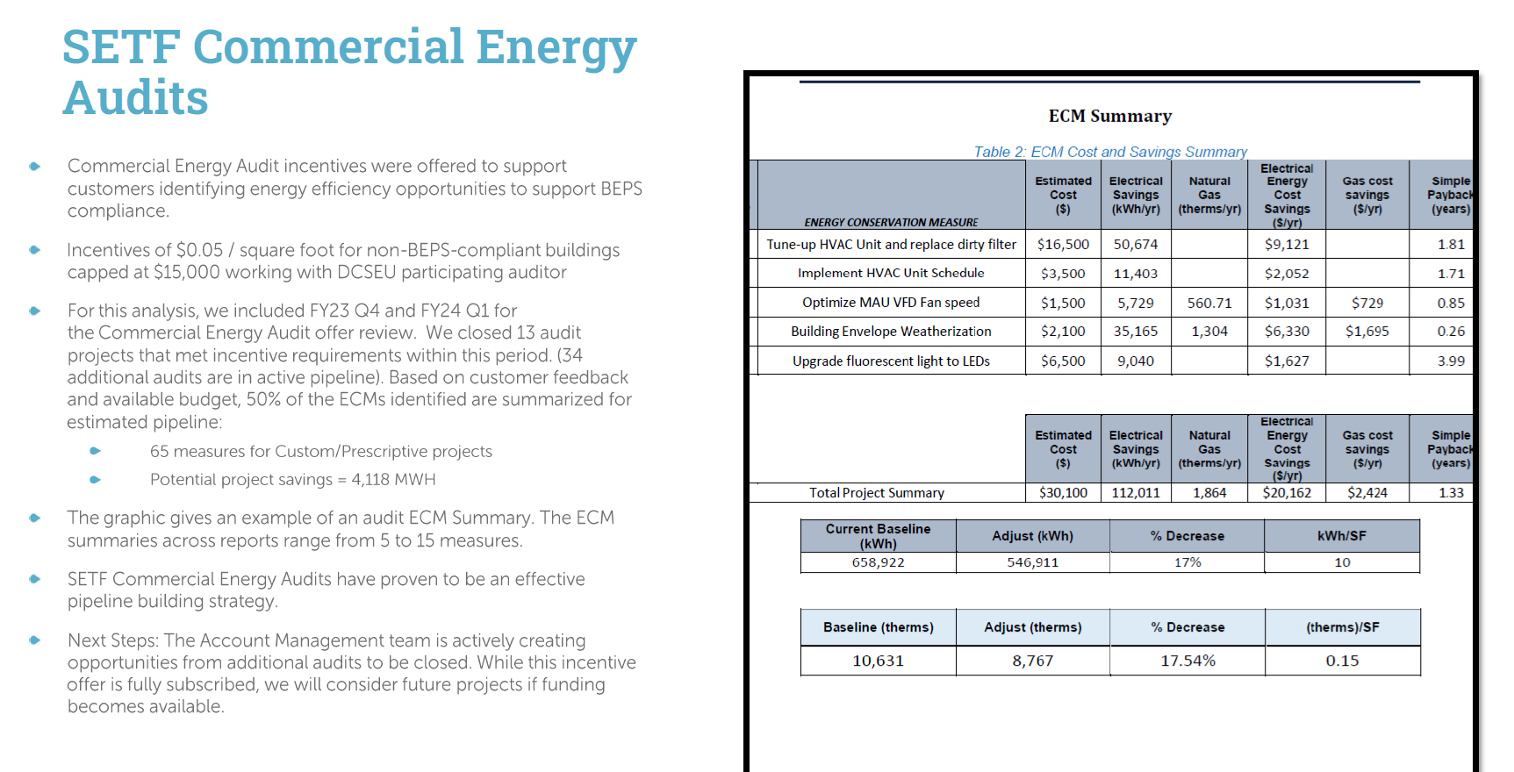
- Vice Chair Dr. Larry Martin observed that the energy audits do not provide any credit towards the DCSEU’s benchmarks but establishes a potential pipeline for pay for performance.
- Patti Boyd (DCSEU) added that once the energy audits are complete, the DCSEU follows up with the customers to get them to move to the next step (such as investing in building automation systems).
- Giuls Kunkel shared that a lot of institutional investors are working towards net zero goals and are being motivated by the 179 D tax deduction which could be a great opportunity to partner with pay for performance.
- Ben Burdick (DCSEU) highlighted that pay for performance is facing obstacles with low building occupancy and building vacancies. Ben offered to follow up with Giuls to continue the conversation around business entry gates.
- Nina Dodge inquired whether there were Federal rebates available for commercial energy audits.
- Ben Burdick (DCSEU) shared that the Federal government does not offer rebates for commercial energy audits.
- Patti Boyd (DCSEU) presented on a new pilot project:
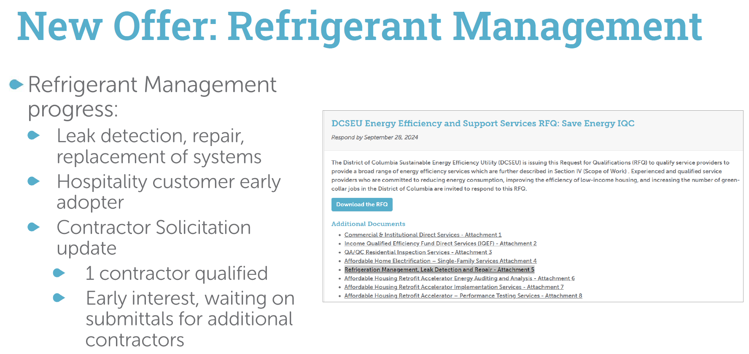
- Nina Dodge inquired whether the DCSEU could encourage the investment of HVAC equipment (heat pumps and mini splits) with less harmful refrigerants.
- Ben Burdick (DCSEU) mentioned that Patti has been looking at systems on a refrigeration side, not necessarily on the heat pump side, but with smaller applications.
- Eric Jones cautioned the DCSEU on anything involving the usage and/or potential storage of propane. Eric mentioned that during a technical issue working group there were members pushing to prohibit the use of propane.
- Giuls Kunkel asked if the DCSEU plans to offer webinars or educational material to help the market understand the dangerous impact of refrigerants.
- Patti Boyd (DCSEU) offered to connect with Giuls offline to discuss further.
- Philana Owusu (DCSEU) presented on the Affordable Home Electrification Program:
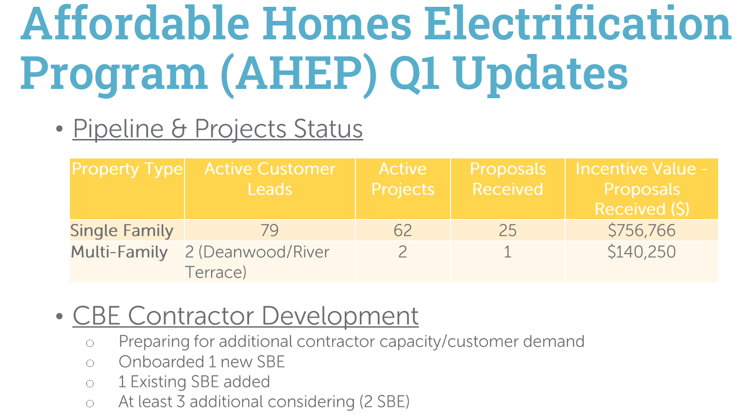
- Jamal Lewis asked about AHEP’s quality assurance and quality control process.
- Philana Owusu (DCSEU) shared that AHEP has two levels of quality assurance:
  - DCSEU contractor inspects the equipment after installation.
  - DOB conducts another inspection.
- Vice Chair Dr. Larry Martin asked:
  - Does the DCSEU have a sense of the cost of efficiency for multifamily properties versus single family?
- Ben Burdick (DCSEU) and Solome Girma (DCSEU) shared that the cost of efficiency depends on the current equipment in the unit, so the pricing varies.
- Nina Dodge asked how the single family and multifamily properties have traditionally been selected for AHEP.
- Philana Owusu (DCSEU) mentioned that applications can be received via DCSEU’s online application portal.
- Solome Girma (DCSEU) added that the multifamily properties in Deanwood and River Terrace get priority and must be approved by DOEE before moving forward.
- Dr. Lance Loncke (DOEE) highlighted that multifamily buildings include 5 units and above.
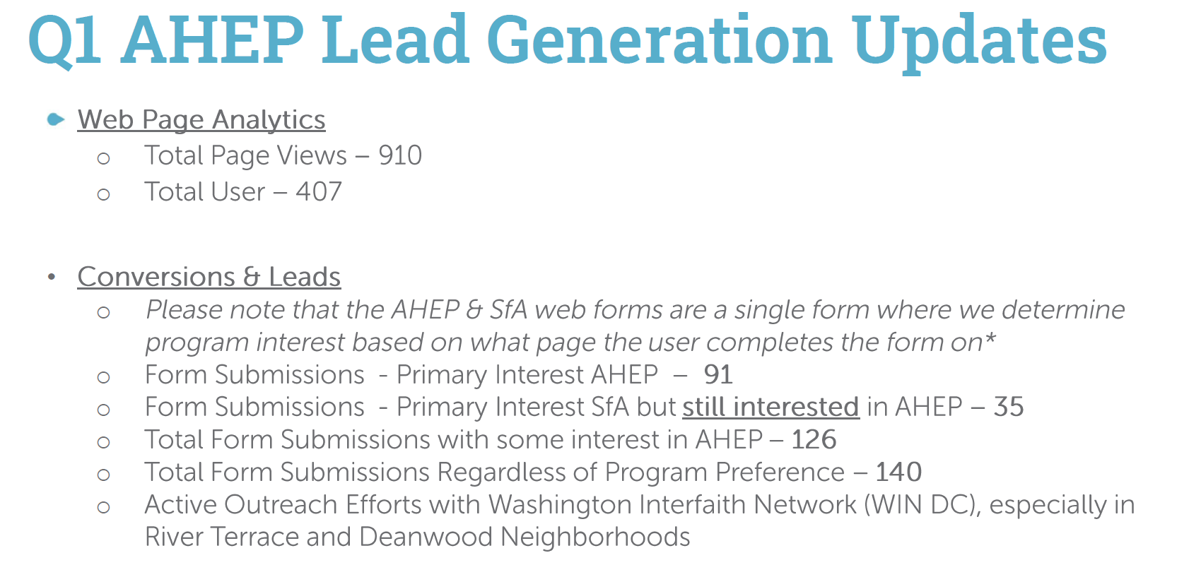
- Philip Haddix (DCSEU) presented on the Affordable Housing Retrofit Accelerator:
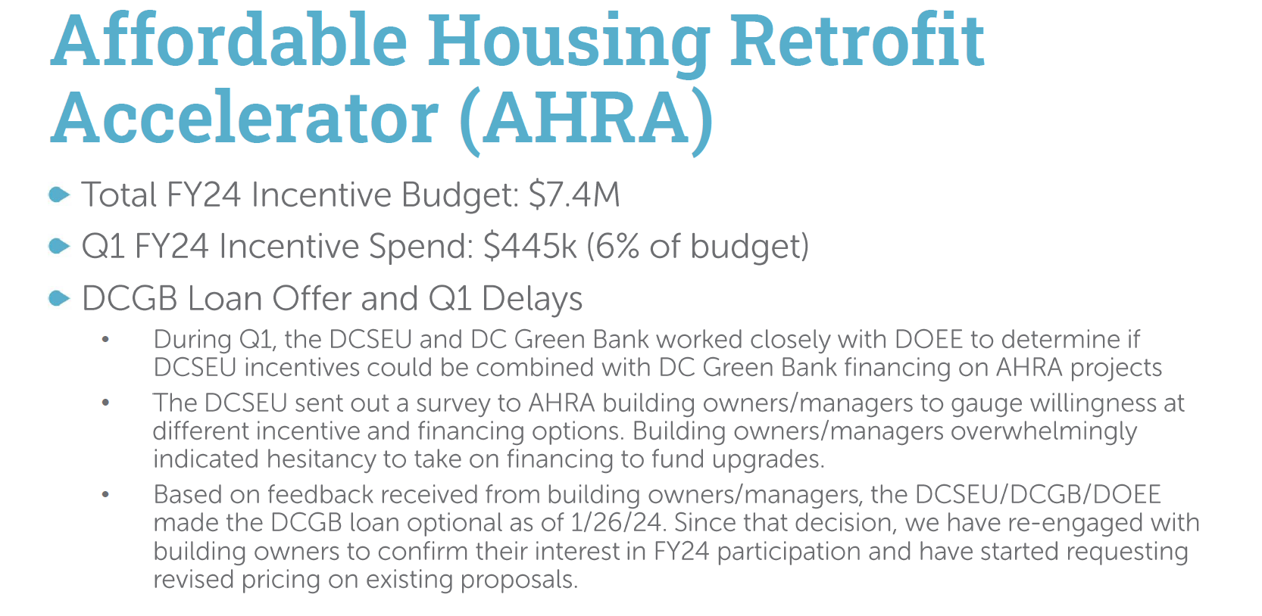
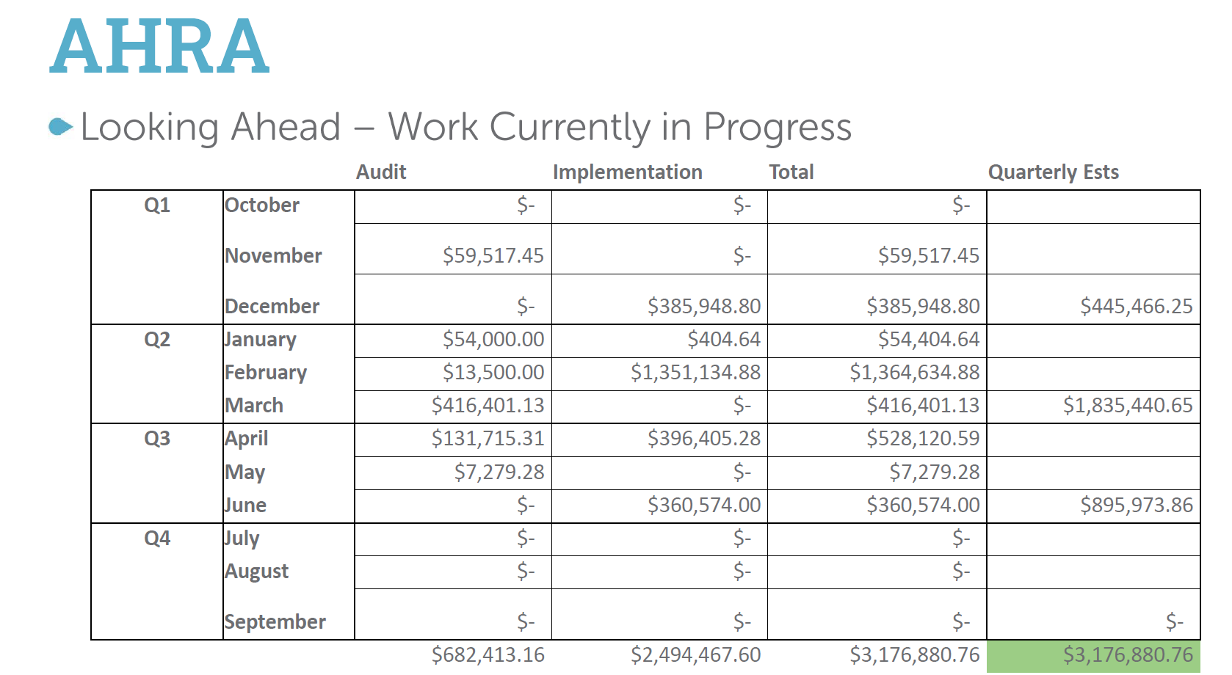
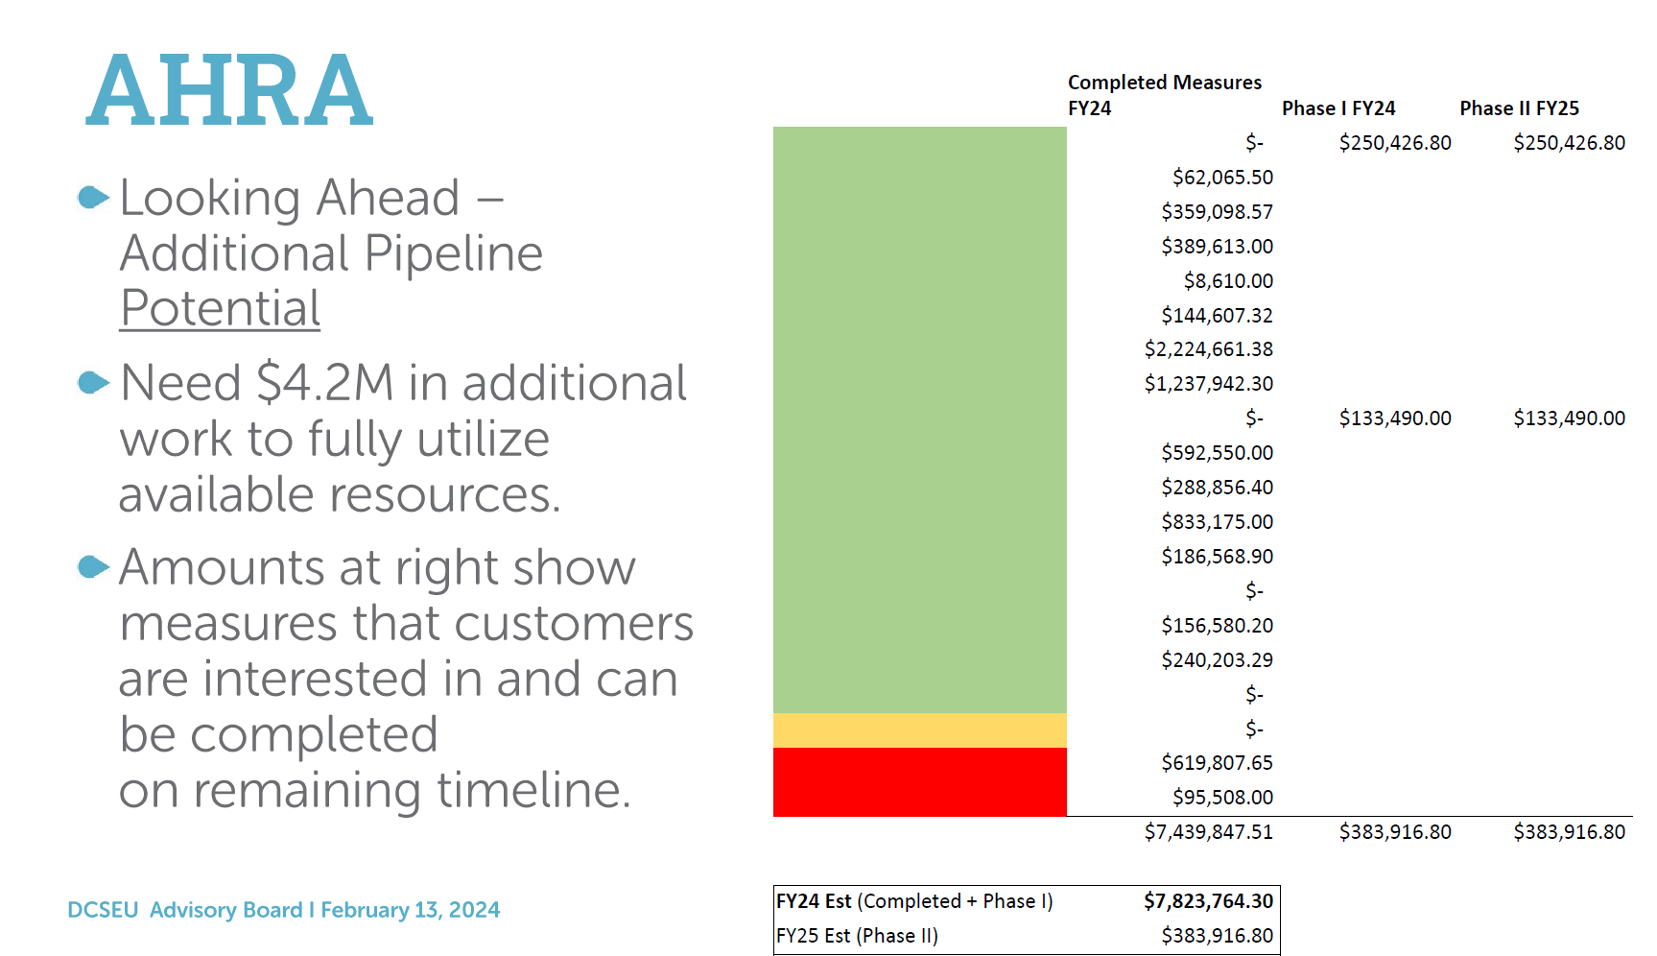

- James Clarke (DCSEU) presented on the Solar for All program:
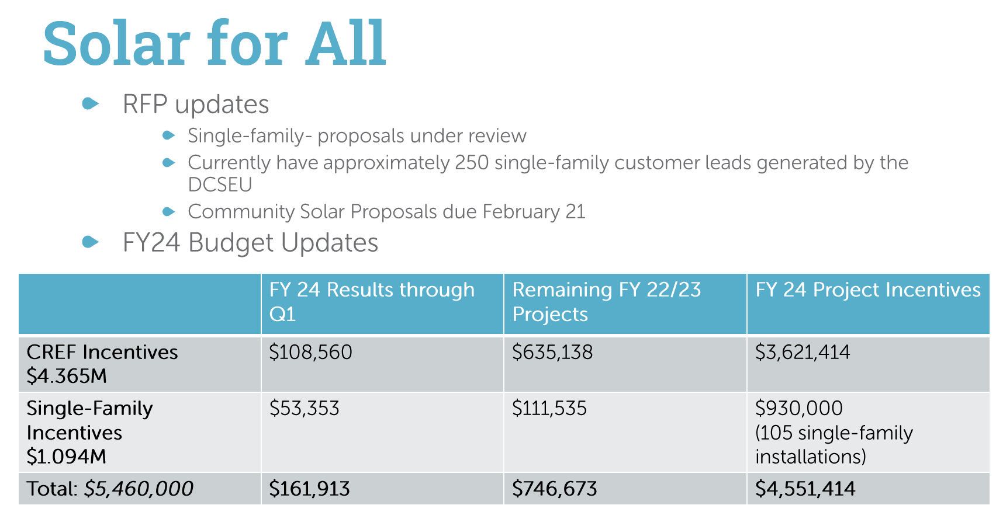
- The Board determined that workforce development updates could be shared during the March meeting.

Committee Updates
- Vice Chair Dr. Larry Martin shared the highlights from the two PSC Committee meetings:
  - Key question: Does the Board want to provide comments to the PSC on the VDER Study? Based on the committee’s conversations, the results and key findings may impact the DCSEU.
  - Next steps: Meet with DCSEU management on 2/16/24 discuss their perceptions of the VDER Study and may draft language for the Board’s consideration.
- Vice Chair Dr. Larry Martin reminded the group that the determination of whether the board submits comments is the responsibility of the Advisory Board, not the PSC Committee.
- Jaleel Shujath shared the highlights from the Workforce Development Committee meeting:
  - The DCSEU provided an update on the marketing and advertising of the train green programs. Given the limited marketing budget, the Committee is working to connect the DCSEU with other groups in the District that are implementing green training and workforce development (such as UDC). The Committee and the DCSEU met with the Workforce Investment Council (WIC) and plans to follow up with WIC in March to discuss more areas for collaboration.

DOEE Oversight Hearing
- Board members determined the oversight hearing would be a great avenue to highlight the Board’s annual report. Vice Chair Dr. Larry Martin to follow up with the wider group on the Board’s testimony.

Follow up Items
- RE+EE Performance Benchmark: Patti Boyd (DCSEU) to share the conversion factor methodology for evaluating current grid mix with Jamal Lewis.
- Business Rebates & Pay for Performance: Ben Burdick (DCSEU) and Solome Girma (DCSEU) to follow up with Giuls Kunkel on strategies for engaging more building owners.
- Refrigerant Management: Patti Boyd (DCSEU) to follow up with Giuls Kunkel on strategies for educating the market on harmful impacts of refrigerants.

Board Action Items
- Approval of Meeting Agenda
- Approval of December Minutes
- Approval to form a subcommittee on workforce development

Future Agenda Items
- Approval of February Meeting Minutes
- DCSEU FY24 Q1 – Workforce Development
- PSC Committee Update
- Legislative Updates
- New Business

Adjournment
- Vice Chair Dr. Larry Martin adjourned the meeting at 12:05 PM.

Acronyms used during this meeting
- AHRA - Affordable Housing Retrofit Accelerator
- ATO - Authorization to Operate
- BSA - Bill Stabilization Adjustment
- CAEA - Clean and Affordable Energy Act of 2008
- CBE - Certified Business Enterprise
- CEM - Certified Energy Manager
- CREF - Clean Renewable Energy Facility
- DCSEU - District of Columbia Sustainability Energy Utility
- DERMS - Distributed Energy Resource Management Systems
- DOB – Department of Buildings
- DOEE - Department of Energy and Environment
- DSLBD - DC Department of Small & Local Business Development
- EEDR – Energy Efficiency and Demand Response
- kW - kilowatt
- MOTA – Mayor's Office of Talent and Appointments
- OPC - Office of the People’s Counsel
- PP2 - PROJECTPipes 2
- PSC - Public Service Commission
- SBCT - Societal Benefit Cost Test
- SEICBP - Sustainable Energy Infrastructure Capacity Building and Pipeline Program
- SETF - Sustainable Energy Trust Fund
- TAG - Technical Advisory Groups
- VPP - Virtual Power Plant
- WGL – Washington Gas Light
Minutes prepared by Jennifer Johnston, DOEE

