Sustainable Energy Utility Advisory Board (SEUAB) Meeting
Monday, October 23, 2023
2:00 PM – 4:00 PM

Call to Order
Chair Bicky Corman called the meeting to order at 2:05 PM, October 23, 2023. Chair Bicky Corman called a quorum of the Sustainable Energy Utility Advisory Board (SEUAB or Board) at 10:06 AM. This was a Microsoft Teams video conference call meeting.

Roll Call/Instructions
Roll call was taken at 2:04 PM and the following people were in attendance:

Board Members
Name | In Attendance? | FY 2024 Regular Meetings  Attendance Record
Bicky Corman - Board Chair (Mayor’s Designee) | Yes | 1/1
Mansi Talwar (Councilmember Allen) | No | 0/0
Sandra Mattavous-Frye (or OPC proxy) | Yes | 1/1
Danielle Gurkin (PSC) | Yes | 1/1
Pending - (Electric Company) | N/A | N/A
Eric Jones (Building Management) | Yes | 1/1
Nina Dodge (Environment) | Yes | 1/1
Jamal Lewis (Low-Income Community) | Yes | 1/1
Jaleel Shujath (Economic Development) | Yes | 1/1
Sasha Srivastava (Renewable Energy) | Yes | 1/1
Giuls Kunkel (Building Construction) | No | 0/0
Dr. Larry Martin (Council Chairperson Mendelson) | Yes | 1/1
Pending – Portia Hurtt (Gas Utility) | N/A | N/A

Other Attendees: Dr. Yohannes Mariam (OPC), Ernest Jolly (DCSEU), Patti Boyd (DCSEU), Angela Johnson (DCSEU), Crystal McDonald (DCSEU), Jahmai Sharp (DCSEU), Ben Burdick (DCSEU), Tamara Christopher (DCSEU), Hussain Karim (DOEE), Lou Hutchinson (VEIC), Dr. Lance Loncke (DOEE), Jennifer Johnston (DOEE), Portia Hurt (WGL)

New Board Members
- Chair Bicky Corman welcomed the newest Board member to the meeting, Kinteshia Scott, Office of the People’s Council.
- Kinteshia Scott (OPC) shared that she serves as Assistant People's Council. She also highlighted that Dr. Yohannes Mariam will be joining the Board meetings on behalf of the People’s Council.
Approval of Agenda
- Chair Bicky Corman requested the Board add voting on a Vice Chair to the agenda.
- Kinteshia Scott (OPC) shared updates on a few PSC formal cases:
  - FC 1160 (energy efficiency and demand response programs for both Pepco and WGL).
    - DCSEUAB submitted comments for Washington gases proposal.
    - Waiting for a Commission decision, because there's currently a dispute between a several parties, including Sierra Club and Washington Gas.
    - There is an additional dispute regarding submitting comments for WGL's actual
application. WGL’s stance is that time has run out for all parties to submit
comments because the comments were due 30 days from their application date.
  - FC 1176 (Pepco multi-year rate plan)
    - Pepco requested about a $180 million rate increase.
    - There are several disputes amongst the parties and all of the other interveners are set to provide some initial testimony on December 11th.
    - This past week, Pepco filed a traditional one-year rate plan that would be used as a comparison to the multiyear rate plan that they filed. That rate plan is for about $108 million / 1 year.
- Chair Bicky Corman moved to approve the agenda and was seconded by Nina Dodge. All were in favor, and none were opposed.

Approval of September Minutes
- Chair Bicky Corman moved to approve the September meeting minutes and was seconded by Eric Jones. All were in favor, none were opposed.

DCSEU FY24 Annual Plan
- Director Ernest Jolly (DCSEU) thanked Chair Bicky Corman and Dr. Lance Loncke (DOEE) for attending VEIC’s Board meeting.
- Ben Burdick (DCSEU) presented on DCSEU’s FY24 Annual Plan:
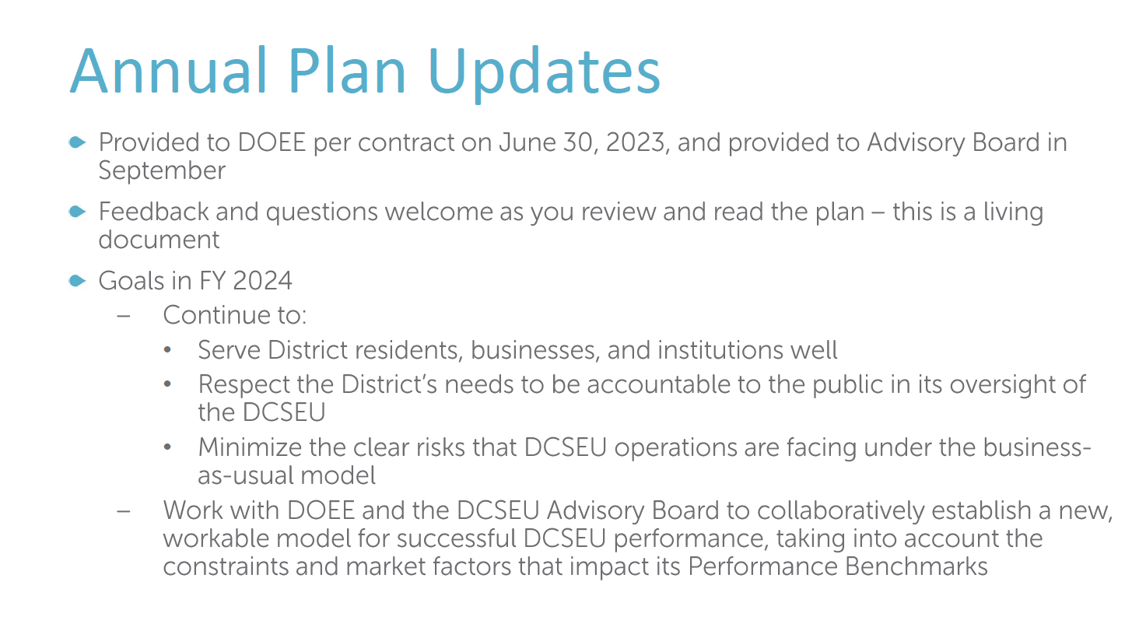
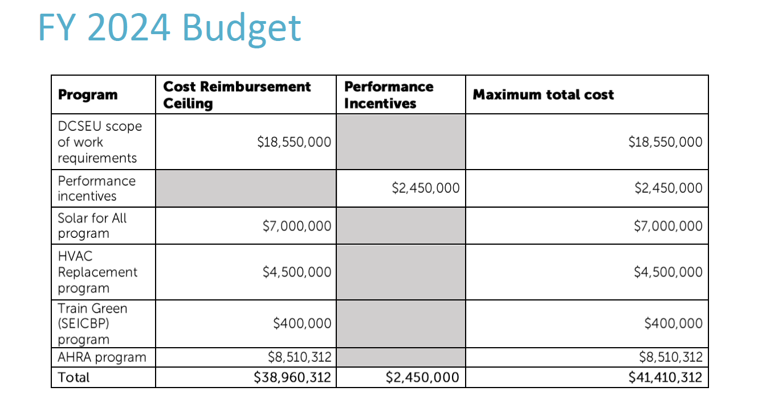
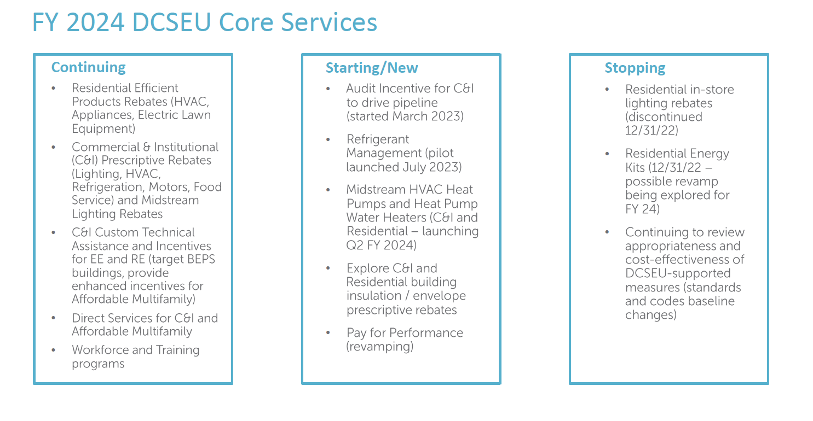
- Nina Dodge requested the DCSEU notify the Board of future workforce graduations.
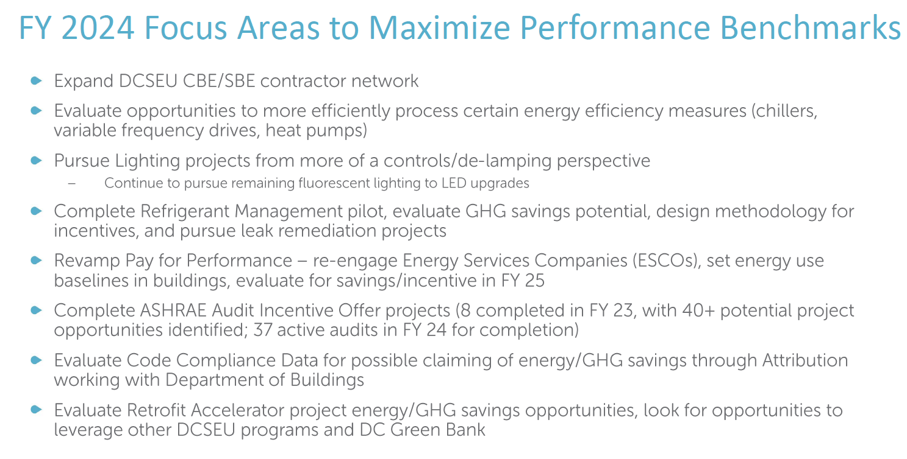
- Chair Bicky Corman asked what the DSCEU meant by attribution (referring to evaluate code compliance data for possible claiming of energy/GHG savings through attribution working with Department of Buildings).
- Patti Boyd (DCSEU) highlighted that there are energy savings between the old code and the new code. The DCSEU provided support both to the market and to the Department of Buildings (DOB) through training to get the code updated. The DCSEU attributes the progress on codes to DCSEU’s influence.
- Eric Jones inquired whether this referred to the DCSEU developing a strategy to encourage industry to give the DCSEU credit for a change in the construction code.
- Patti Boyd (DCSEU) shared that the DCSEU served on the technical advisory groups (TAG) to get the building codes as stringent as possible. The DCSEU also provided training on how DOB could better implement and streamline buildings coming into compliance with the code.
- Eric Jones asked if DCSEU is saying that it should get credit for introducing a measure that the TAG decided to take up.
- Director Ernest Jolly (DCSEU) shared that it is not about being recognized for advocating for the change in the code, it is that DCSEU can now help do the work to get the results.
- Patti Boyd (DCSEU) clarified that the DCSEU did not change the code from X to Y, but the DCSEU was part of the TAGs and then once the codes come into place, the DCSEU created trainings for DOB staff (because DOB has not had the capability to develop the trainings themselves). The DCSEU provided a lot of peripheral support.
- Chair Bicky Corman highlighted that the group has been talking for a long time about the DCSEU requiring a sea change. The DCSEU had worked on the low hanging fruit and accomplished advancing the District’s energy efficiency, but now it is time to look elsewhere. She asked if the DCSEU could give the Board a sense out of these bullets which are going to make a sea change?
- Ben Burdick (DCSEU) shared that the refrigerant management pilot has potential to be a sea change because of how harmful the emissions are and pay for performance. Also, as mentioned in the strategic plan, the DCSEU will continue to evaluate our things such as carbon sequestration, concrete, and electrifying off-road equipment.
- Director Ernest Jolly (DCSEU) added that the HVAC replacement program, now the Home Affordable Electrification, is ramping up from 50 households per year to 200 and it may increase to 1,000 household per year which would be a sea change as it relates to health.
- Nina Dodge asked if the DCSEU could also incentivize heat pump water heaters that run on clean or much cleaner refrigerants.
- Patti Boyd (DCSEU) highlighted that the idea is to incentivize all the ways that can either reduce the amount of refrigerants or other harmful global warming pollutants leaking into the environment.
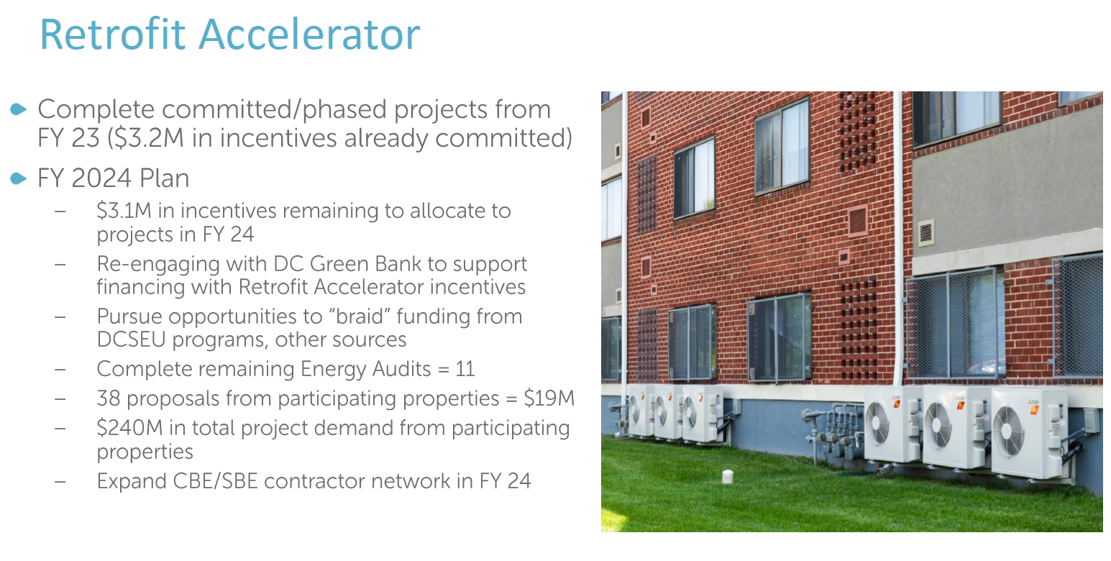
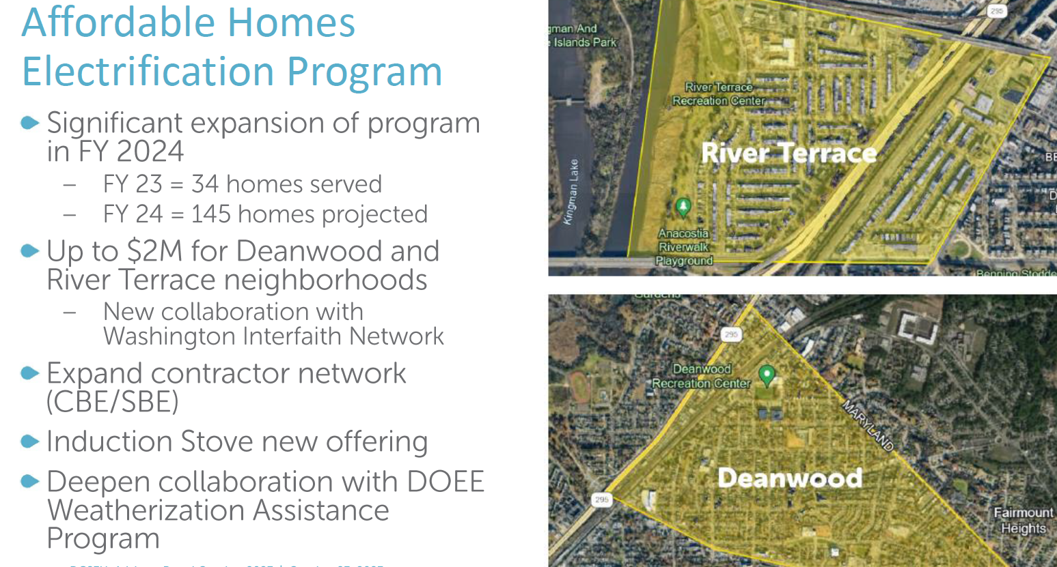
- Jamal Lewis asked what DCSEU’s efforts look like to expand the contractor capacity for retrofit accelerator and the affordable home electrification program. Also, for Solar for All, he shared that he would like to be a thought partner to help think about the opportunity to leverage the low-income bonus credit program, Section 48(e). Jamal mentioned that on a prior slide 4.5 million was listed as the budget for the Affordable Home Electrification and then up to 2 million could be used for target neighborhoods.
- Ben Burdick (DCSEU) shared that yes, 4.5 million is the budget for the Affordable Home Electrification program and up to 2 million will be used in the Deanwood and River Terrace neighborhoods. Ben mentioned that he would welcome a thought partnership and discussion on low-income tax credits. The DCSEU has been looking into how to incorporate the low-income tax credit into Solar for All and the opportunity to lower the amount of incentive that is offered to developers and contractors. Ben also highlighted that it will be a challenge to build contractor capacity but it is something where the DCSEU has a lot of great insight and resources from train green and workforce development programs.
- Eric Jones asked what type of next steps the DCSEU is taking to make sure that the people participating in this training are not just getting short term entry level jobs but have career changing structures that we have not seen over the last decade.
- Director Ernest Jolly (DCSEU) shared that this year participants in the workforce development program had about an 87% employment rate. Also, through the Train Green program, the DCSEU is working with CBE’s to build skill sets and certifications that allows participants to grow within their CBE.
- Ben Burdick (DCSEU) shared that the DCSEU would be happy to invite someone from the Advisory Board to come speak to one of the workforce development cohorts and welcomed Eric to come speak with them about AOBA.

DCSEU Benchmark Review
- Dr. Lance Loncke (DOEE) provided an overview of DCSEU benchmark adjustments:
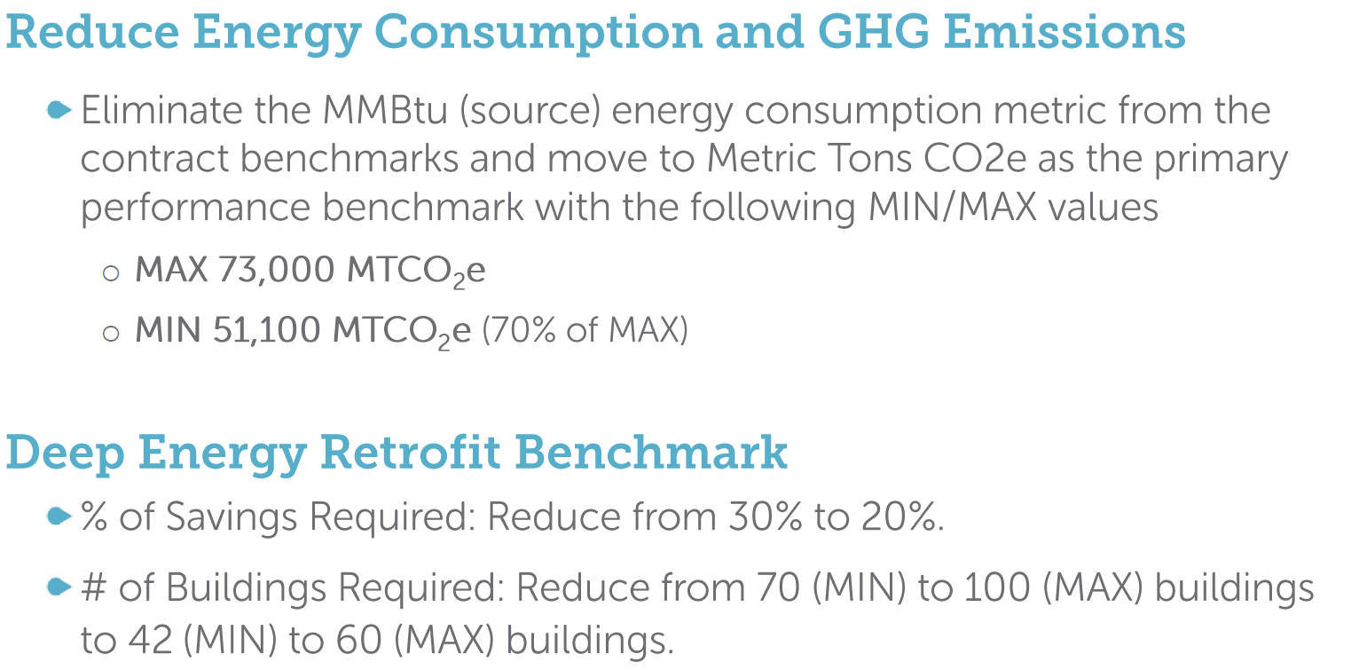
- Nina Dodge asked if there was a downside to converting from a MMBtu measure to GHG.
- Dr. Lance Loncke (DOEE) shared that DCSEU’s leaf blower or refrigerant incentives, could not be counted toward the MMBtu measure, but both can contribute is to the GHG benchmark. With the GHG benchmark enegry savings as well as pollution reducation can be captured.
- Jamal Lewis asked how the Deep Energy Retrofit Benchmark was evaluated to get to the new 20% enegry savings.
- Dr. Lance Loncke (DOEE) highlighted that in order to comply with BEPS a building must complete at least a 20% energy reduction. Additionally, the 20% aligns with ICAST’s deep energy retrofit program (operating on behalf of Pepco).
- Jamal Lewis asked how the 60 building max was derived.
- Dr. Lance Loncke (DOEE) mentioned that this bechmark is starting in year three of DCSEU’s contract. Right now the DCSEU has only completed one or two deep energy retrofits so DOEE felt that 60 was still an aggressive goal.

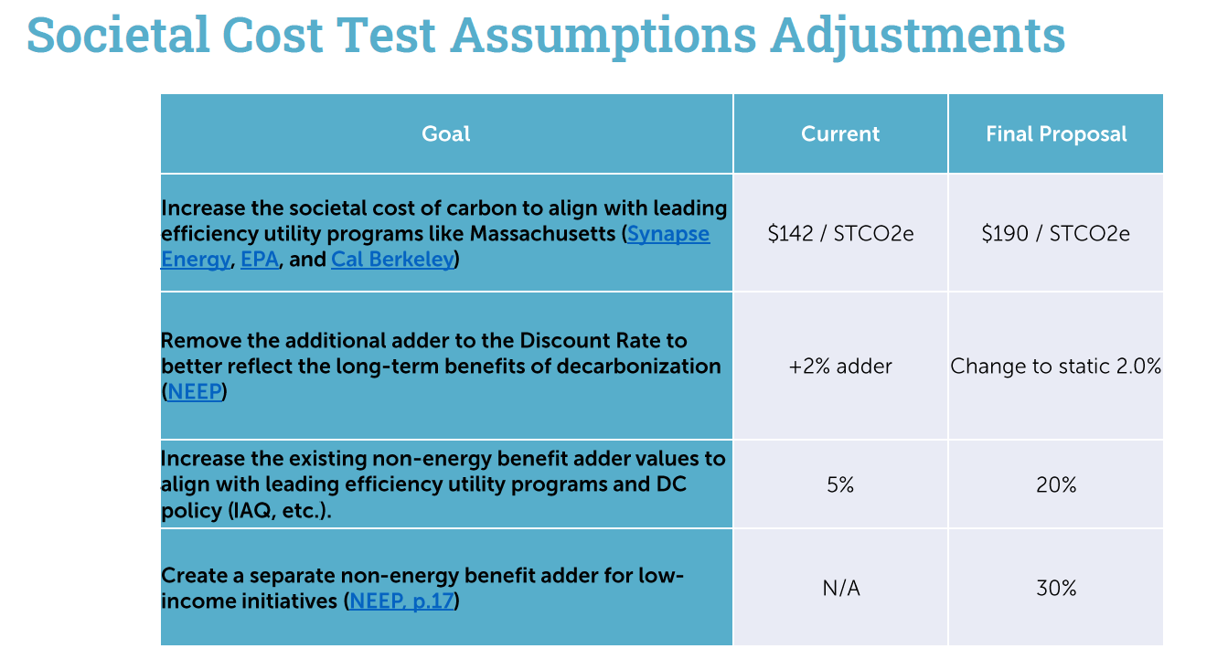

- Danielle Gurkin (PSC) shared that the Commission is interested in getting a final report or the underlying assumptions that th DSCEU is using for the Societal Benefit Cost Test (SBCT).
- Dr. Lance Loncke (DOEE) clarified that the PSC has a separate SBCT being developed for the utilities, the DCSEU has its own SBCT, and the third-party evaluator has a SBCT to test DCSEU’s performance. The DCSEU is not required to meet the SBCT until the end of the five year contract. Dr. Loncke aslo highlgihted that the SBCT assumption were already shared with the PSC when Alex Fisher requested this information. Dr. Loncke shared that he could forward what was porvided to Alex to Danielle.
- Jamal Lewis aksed if the SCBT was a regulatory requirement.
- Dr. Lance Loncke (DOEE) confirmed that the SCBT was a requirment of the Clean and Affordable Energy Act of 2008 (CAEA). So when the SBCT is set to equal a ratio of one or greater, anything above one tells us that for every dollar being spent, you are getting more than a dollar in savings.
- Chair Bicky Corman highlghted that it is very important to have an evaluator so the Board can see the progress DCSEU is making.
- Dr. Lance Loncke (DOEE) requested the Board provide feedback on these proposed benchmark changes by the Board’s next meeting (Tuesday, November 14).
- Nina Dodge moved to have a special meeting to discuss the SBCT and request the PSC wiegh in on their opinion of the changes. This was seconded by Chair Bicky Corman. All were in favor, and none were opposed.
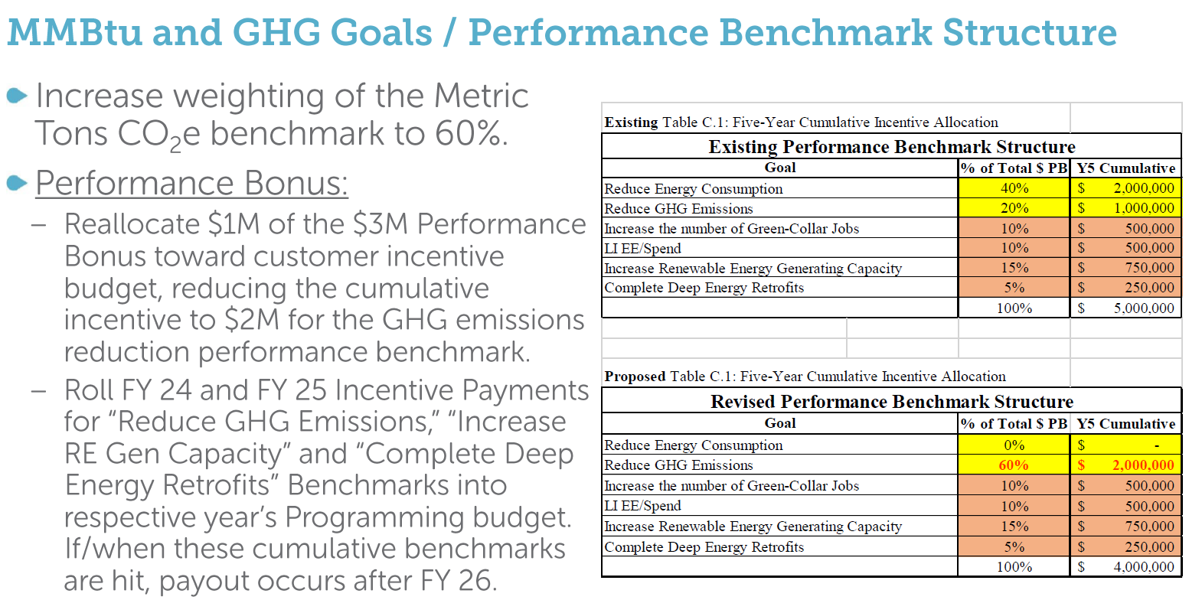

Vice Chair Discussion
- Chair Bicky Corman moved to nominate Dr. Larry Martin as Vice Chair; none were opposed.

DCSEUAB FY22 Annual Report
- Jennifer Johnston outlined the below timeline for the Board’s FY22 annual report:
  - COB 10/27/23: Board members provide their feedback on the draft to Jennifer.
  - COB 10/31/23: Jennifer distributes the final version to Board members.

Board Action Items
- Approval of Meeting Agenda
- Approval of September Minutes
- Approval of Special Meeting (to discuss DCSEU’s SBCT)
- Approval of new Vice Chair, Dr. Larry Martin

Future Agenda Items
- Approval of October Meeting Minutes
- Approval/Feedback on DCSEU Performance Benchmarks
- DCSEU’s FY23 Q4 Update
- Board’s FY22 Annual Report
- Discussion of Board providing comments on WGL’s EEDR application and/or Pepco’s Climate Plan

Adjournment
- Chair Bicky Corman adjourned the meeting at 3:58 PM.

Acronyms used during this meeting
- ATO - Authorization to Operate
- CAEA - Clean and Affordable Energy Act of 2008
- CREF - Clean Renewable Energy Facility
- DCSEU - District of Columbia Sustainability Energy Utility
- DOB – Department of Buildings
- DOEE - Department of Energy and Environment
- EEDR – Energy Efficiency and Demand Response
- MOTA – Mayor's Office of Talent and Appointments
- OPC - Office of the People’s Counsel
- PSC - Public Service Commission
- SBCT - Societal Benefit Cost Test
- SETF - Sustainable Energy Trust Fund
- TAG - Technical Advisory Groups
- WGL – Washington Gas Light
Minutes prepared by Jennifer Johnston, DOEE

