Sustainable Energy Utility Advisory Board (SEUAB)
Public Service Commission (PSC) Committee Meeting
Tuesday, January 23, 2024
10:00 AM – 11:00 AM

Roll Call/Instructions
Roll call was taken at 10:03 AM and the following people were in attendance:

Board Members
Name | In Attendance? | FY 2024 Special Meetings  Attendance Record | FY 2024 Committee Meetings Attendance Record | FY 2024 Regular Meetings  Attendance Record
Pending - Board Chair (Mayor’s Designee) | N/A | N/A | N/A | N/A
Mansi Talwar (Councilmember Allen) | Yes | 1/1 | 1/1 | 3/4
Sandra Mattavous-Frye (or OPC proxy) | Yes | 1/1 | 1/1 | 3/4
Danielle Gurkin (PSC) | Yes | 0/1 |  | 2/4
Pending - (Electric Company) | N/A | N/A | N/A | N/A
Eric Jones (Building Management) | Yes | 0/1 | 1/1 | 4/4
Nina Dodge (Environment) | Yes | 1/1 | 0/1 | 4/4
Jamal Lewis (Low-Income Community) | Yes | 1/1 | 0/1 | 4/4
Jaleel Shujath (Economic Development) | Yes | 1/1 | 1/1 | 4/4
Sasha Srivastava (Renewable Energy) | Yes | 1/1 | 1/1 | 4/4
Giuls Kunkel (Building Construction) | Yes | 1/1 | 0/1 | 2/4
Dr. Larry Martin – Vice Chair (Council Chairperson Mendelson) | Yes | 1/1 | 1/1 | 4/4
Pending – (Gas Utility) | N/A | N/A | N/A | N/A

Other Attendees: Crystal McDonald (DCSEU), Tamara Christopher (DCSEU), Solome Girma (DCSEU), Thomas Bartholomew (DOEE), Jennifer Johnston (DOEE), Dr. Lance Loncke (DOEE), Hussain Karim (DOEE), Dr. Yohannes Mariam (OPC), Kintéshia Scott (OPC), Portia Hurtt (WGL)

FC1130 Board Discussion
- Vice Chair Dr. Larry Martin highlighted the purpose of the Public Service Commission (PSC) Committee -> to address any ongoing or upcoming PSC items that may be of interest to the Board.
- Vice Chair Dr. Larry Martin shared the following slide deck summarizing the key findings and recommendations from the Synapse’s VDER Study:
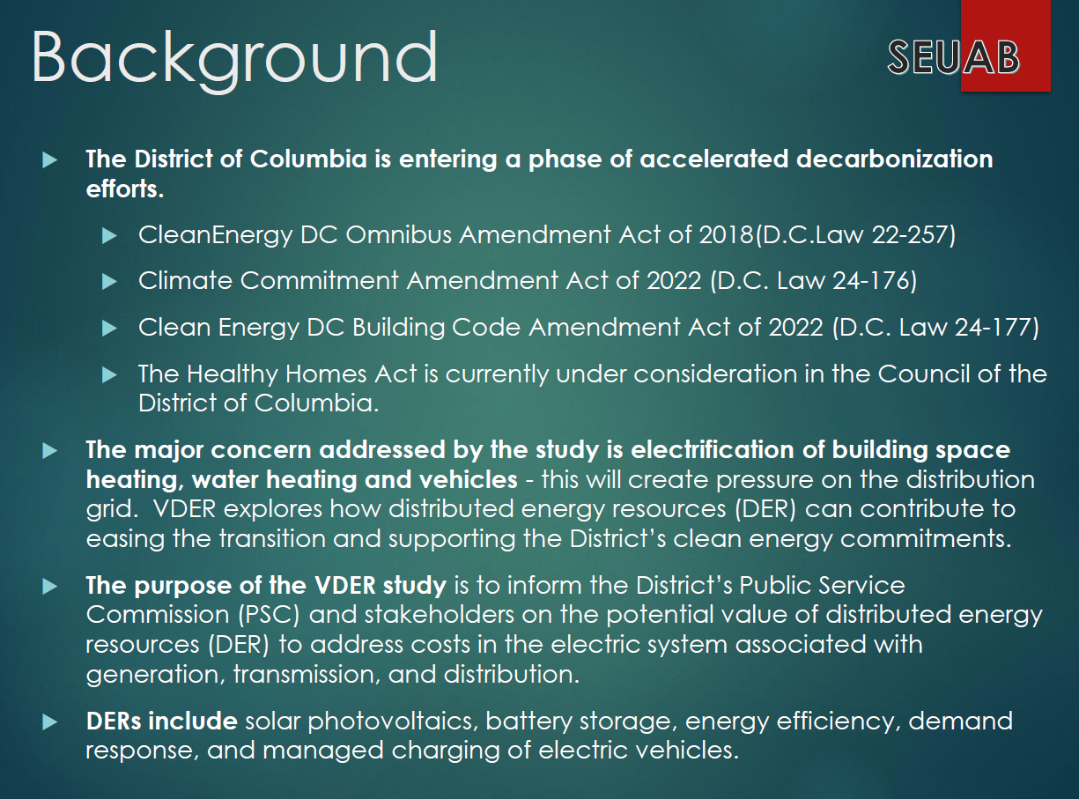
- Mansi Talwar provided a summary of the study’s findings:
  - Peak cooling and heating loads will increase significantly as vehicle and building electrification increase
  - Suggestions on how to address peak loads, such as incorporating more battery storage
- Vice Chair Dr. Larry Martin asked the Board to focus on the fourth finding:
  - Because large distribution capacity projects are relatively expensive, and because they are driven by the peak hour of load, “needle” peaks that cause the feeder to exceed its normal rating during only a few overloaded hours are among the most expensive events in terms of $/MWh. These peaks have the potential to drive hundreds of millions of dollars of capacity investment across the District when a few hours of relief could defer or avoid the upgrade. Because the large cost of a distribution system upgrade is spread across more hours of pressure in our “Maximum Pressure” scenario, it may make more sense to invest in upgrades to the system. However, when the pressure is partially reduced, such that only a few remaining hours are creating pressure, the same logic applies: the hourly value of responsive load curtailment is much greater.

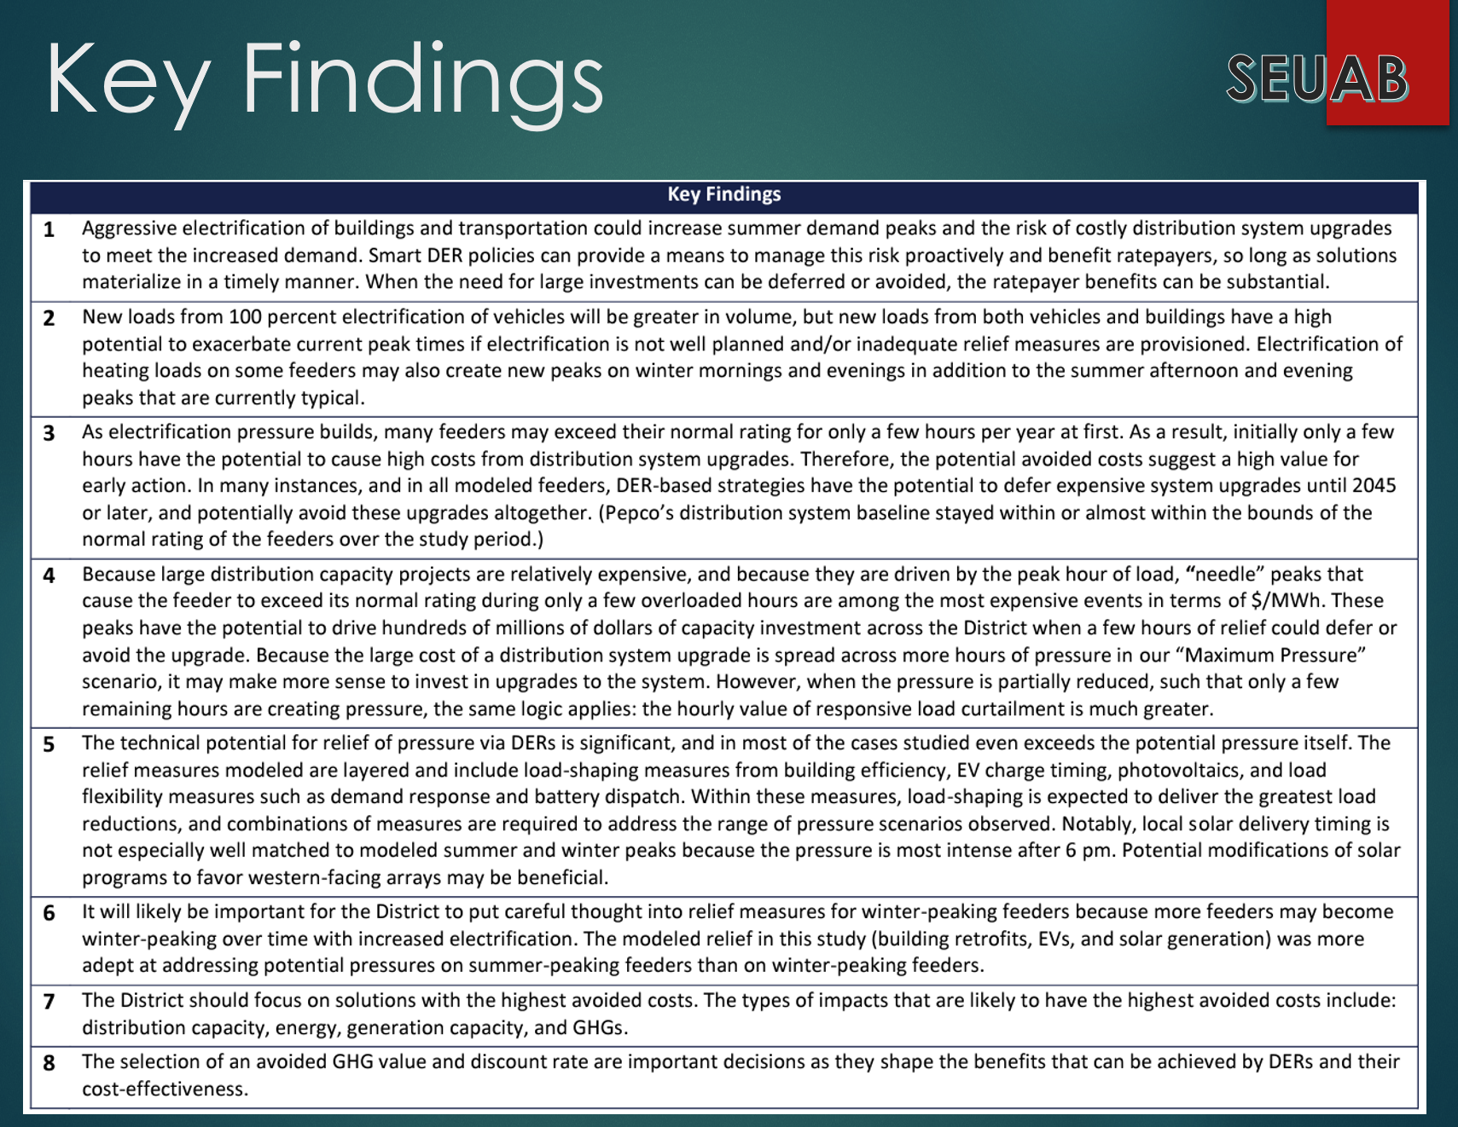

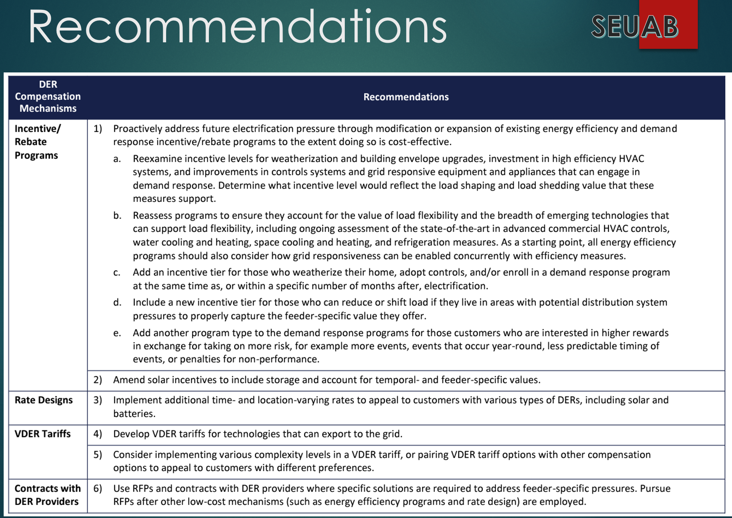
- Mansi Talwar shared her experience from implementing weatherization and building envelope upgrades (as it pertained to recommendation #1):
  - The building envelope is a fraction of the scope of work because there are not any incentives for commercial weatherization, meaning a high cost for a low-yield of savings. Consultants emphasize the importance of first reducing the load and then eliminating fossil fuels.
  - HVAC systems can be expensive and have a medium impact of energy savings.
  - Building control systems can have higher return because the controls give a lot of flexibility to a building owner to work on reducing their peak demand significantly.
- Vice Chair Dr. Larry Martin asked the group if anyone saw recommendation #1 as not relevant to the DCSEU.
- Mansi Talwar mentioned that recommendation #1 is relevant to the current state of things and resonates with Clean Energy DC 2.0 (in terms of peak load management). Most of the DCSEU programs are driven based on the savings goals, peak demand is not a current contract goal. Mansi added that a peak demand incentive would be helpful for a building owner.
- Dr. Lance Loncke (DOEE) shared that the DCSEU is not capable of doing direct peak demand programs because the DCSEU does not have access to real time energy usage data. Pepco has EEDR programs pending before the PSC and peak demand is one of the items Pepco intends to address. Dr. Loncke highlighted how time-of-use (TOU) rates would need to be implemented to create a peak load incentive program.
- Vice Chair Dr. Larry Martin asked the group if anyone saw recommendation #2 as not relevant to the DCSEU.
- Dr. Lance Loncke (DOEE) highlighted that the DCSEU is focused on helping the District accelerate solar deployment. The majority of the DCSEU’s solar deployment is through the Solar for All (SFA) program where 100% of the energy generated is given to low-income residents to offset their energy usage. Last year, Council included a storage mandate where a portion of the SETF funding must go toward storage deployment. Right now, the DCSEU is incorporating storage in 7-10 homes annually (in conjunction with SFA). Dr. Loncke raised that to incentivize the market to build batteries, there needs to be a TOU rate policy.
- Dr. Lance Loncke (DOEE) inquired whether the Synapse’s VDER Study mentioned the role of energy efficiency because a lot can be accomplished through energy efficiency and reduce the need for Pepco to add additional substations (and eliminate the need to increase electric rates).
- Vice Chair Dr. Larry Martin confirmed that the Synapse’s VDER Study did not call out the large impact or potential of energy efficiency.
- Eric Jones shared that while the group is discussing reducing energy usage, Council is pushing more items on the grid through electrification which is not sustainable or realistic.
- Thomas Bartholomew (DOEE) asked if Eric was saying the electrification plans were unsustainable.
- Eric Jones mentioned that the group is talking a lot about energy reduction, peak, and non-peak usage, and when looking at increasing EV deployment, all the EV's cannot be charged during non-peak hours. The District policy is saying to decrease energy consumption, but more items are being added to the grid.
- Thomas Bartholomew (DOEE) shared:
  - Part of the reason for trying to reduce peak building load is because of the understanding that other loads (EVs for example) will be coming online.
  - Energy efficiency tends to be the cheapest way to reduce energy consumption and there is quite a bit of runway to reduce loads from buildings and energy.
  - It is possible to charge most EV’s during non-peak because that is when most cars are parked for the longest period of the day.
- Vice Chair Dr. Larry Martin agreed electrification is going to be a huge challenge and adjusting the currently fed gasoline or gas lines to the electrical grid has the potential to hugely increase demand. Managing the demand is a big part of the challenge and emphasizes the whole question behind what the value of DER is:
  - Can it contribute in a constructive way?
  - What are the incentives that could shape a free market economy?
- Dr. Lance Loncke (DOEE) shared that policymakers have shifted focus to decarbonization where the only route to complete that climate goal is to move the District from gas to electric.
- Vice Chair Dr. Larry Martin asked the group if anyone disagreed with Lance’s observation. All Board members agreed (Council focusing more on decarbonization rather than energy efficiency).
- Vice Chair Dr. Larry Martin focused on recommendation #6:
  - Use RFPs and contracts with DER providers where specific solutions are required to address feeder-specific pressures. Pursue RFPs after other low-cost mechanisms (such as energy efficiency programs and rate design) are employed.
- Vice Chair Dr. Larry Martin asked the group
  - Could the DCSEU move into a DER program described in recommendation #6?
- Dr. Lance Loncke (DOEE) shared that VEIC, the entity managing the DCSEU, is capable
of applying to any such contracts that the utilities or the PSC publish. Dr. Loncke highlighted that if errors were identified in a specific location, where pressures were on certain feeders or distribution networks, the DCSEU could focus its programs and initiatives in that specific area. Dr. Locke provided an example:
  - When the DCSEU first participated in SFA, there were only two solar systems east of the river, but after the DCSEU focused its deployment efforts to ward 7 and 8, now there are hundreds of solar systems.
- Vice Chair Dr. Larry Martin suggested the committee reconvene to determine whether the Board would like to submit comments on the findings or recommendations.

Future Agenda Items
- Determine whether the Board would like to comment on FC1130
  - Follow up discussion on key finding #4.
  - Follow up discussion on recommendation #1, #2, and #6.

Adjournment
- Vice Chair Dr. Larry Martin adjourned the meeting at 11:00 AM.

Acronyms used during this meeting
- AHRA - Affordable Housing Retrofit Accelerator
- ATO - Authorization to Operate
- BSA - Bill Stabilization Adjustment
- CAEA - Clean and Affordable Energy Act of 2008
- CEM - Certified Energy Manager
- CREF - Clean Renewable Energy Facility
- DCSEU - District of Columbia Sustainability Energy Utility
- DER - Distributed Energy Resource
- DOB – Department of Buildings
- DOEE - Department of Energy and Environment
- DSLBD - DC Department of Small & Local Business Development
- EEDR – Energy Efficiency and Demand Response
- MOTA – Mayor's Office of Talent and Appointments
- OPC - Office of the People’s Counsel
- PP2 - PROJECTPipes 2
- PSC - Public Service Commission
- RFP – Request for Proposals
- SBCT - Societal Benefit Cost Test
- SEICBP - Sustainable Energy Infrastructure Capacity Building and Pipeline Program
- SETF - Sustainable Energy Trust Fund
- VPP - Virtual Power Plant
- WGL – Washington Gas Light
Minutes prepared by Jennifer Johnston, DOEE

