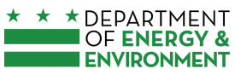
(For DC DOEE Use Only)

Date Received

Beneficiary’s Project ID

District of Columbia Volkswagen Environmental Mitigation
DEAL-DERA Program – Agency Application for Funding

The District Electrification And Low-NO_{X} (DEAL) – Diesel Emissions Reeducation Act (DERA) Program (DEAL-DERA Program) provides funds to District agencies to replace an older vehicle with a more emission-efficient vehicle with the goal of reducing oxides of nitrogen (NO_{X}) emissions, other air pollution, and greenhouse gases. The funding is a partial subsidy for purchase of a new qualifying vehicle(s) using both Volkswagen Trust Funds and Diesel Emission Reduction Act (DERA) funds.

Your signature on this application represents your agency’s commitment to enter into a Memorandum of Understanding (MOU) with DOEE to replace one or more vehicles eligible for funding under the national Volkswagen Settlement and DERA. An eligible vehicle must be District-owned and must presently provide regular service in the District.

Please fill out this short form and sign (or e-sign) it. Section 1 requires you to provide information for your outgoing (used) vehicle(s), and Section 2 requires information on your agency. Appendix A addresses the eligibility criteria for this program’s funding. Appendix B defines the terms we use in this form.

Important Program Information

- Initial round of proposals will be accepted through April 16, 2021.
- Eligible projects will be identified in order of submittal of completed applications.
- Funding is available on a first-come, first-served basis.
- Awarded funds must be used within one year of signing the MOU, unless an extension is granted by DOEE.
- Priority will be given to a replacement vehicle that is electric.
- There may be a second round of funding.
- For information on the District of Columbia DEAL-DERA Program, please click here: District of Columbia Beneficiary Mitigation Plan, updated March 2021.
Please contact Brittany Whited, DOEE at brittany.whited@dc.gov or 202-505-0042 with any questions.

Section 1: Outgoing Vehicle Information and Documentation

Please list the vehicles that you wish to replace or repower under the DEAL-DERA Program. DOEE will use this information to determine outgoing vehicle eligibility— each eligible outgoing vehicle must be District-owned, must be operated by a District agency for agency business, and must meet all eligibility criteria identified in Appendix A.

Vehicles proposed for replacement or repower

Current Vehicle Class | Current  Model | Current  Model Year | Current  DC Asset # | Mileage | Current Fuel Type | Proposed Replacement Fuel Type | Estimated Funding Level

In order to complete an MOU for funding, your agency will have to provide documentation of the following for each vehicle to be replaced or repowered. If you do not have this information at hand, you will need to collect it before DOEE will sign an MOU:

- Mileage and fueling records
- Vehicle registration document and registration history (showing ownership)
- Scrappage plan (The MOU must state how you will later prove that you scrapped the vehicle according to your plan, after replacement or repowering)

Section 2: Agency Information

Your Agency:
Your Project Title (e.g. “Bus replacement”):
Project Location (Wards):
Agency Mailing Address:
City: |  | State: | Zip:
Agency representative (Senior staff from Project Agency):
Daytime Phone: | Alternate Phone: |  |  | Email:

Agency Director’s Signature

The Agency Director’s (e-)signature certifies that the agency agrees to all the program requirements, that the information provided is accurate, and that the agency, if eligible, will sign an MOU with DOEE as soon as practicable, as a precondition for funding.

Agency Director print name: ___________________________________________

Agency Director signature: ____________________________________________

Date: ____________

Filename: 00 5303 dc doee deal-dera application form.docx

Rev. 03/2021

Appendix A: Eligibility Criteria

The table below describes the eligibility requirements and available funding amounts for outgoing and replacement vehicles in each replacement category. See Section 1, on page 2, of the Agency Application for Funding for more information on outgoing vehicle documentation requirements.

Outgoing Vehicle Eligibility and Replacement Vehicle Service Criteria | Funding amount per vehicle
Exact funding level granted will vary based on number of vehicles replaced and funding availability

Outgoing Vehicle Eligibility:  1992-2009 engine model year Class 5-8 Local Diesel Highway Vehicles, including trucks, and buses  Replacement Vehicle:  Vehicle of the same class as the outgoing vehicle, but with an all-electric engine  Replacement Vehicle Service Criteria:  - The vehicle must be used primarily for routes in Wards 7 and 8, for a period of at least 6 years. The vehicle can also be used for routes outside Wards 7 and 8.  - The vehicle will have signage displaying the health benefits of the vehicle.  - An agency receiving funds must provide at least six asthma outreach/educational events over a six-year period, irrespective of the number of vehicles purchased. | Up to 45% of the total cost of replacement

Appendix B: Definitions for this Application
Electric: powered exclusively by electricity provided by a battery, fuel cell, or the grid.

School Bus: The term has the meaning recognized by the National Highway Transportation Safety Administration (NHTSA). This includes a diesel powered school bus of Type A, B, C and D. To be eligible as a school bus, a vehicle shall meet the NHTSA definition of a school bus, found at https://one.nhtsa.gov/nhtsa/whatsup/tea21/tea21programs/pages/PupilTransportation.htm. This definition includes: 1) A bus that is used for purposes that included carrying students to and from school or related events on a regular basis; 2) Be identified with the words “School Bus”; and 3) Be painted National School Bus Glossy Yellow.

Transit Bus: A highway vehicle that is a medium or heavy duty bus that transports people as part of a transit system. This includes a diesel powered medium-duty and heavy-duty transit bus meeting the gross weight rating for a medium-duty or heavy duty truck.
Medium-duty or heavy-duty truck: A diesel highway vehicle. This includes a diesel powered medium-duty and heavy-duty highway vehicle with gross vehicle weight rating (GVWR) as: Class 5 (16,001 -19,500 lbs GVWR); Class 6 (19,501 - 26,000 lbs GVWR); Class 7 (26,001 - 33,000 lbs GVWR); or Class 8 (33,001 lbs GVWR and over).

Scrapped: To render inoperable. Preferably a scrapped vehicle’s material/components will be recycled. There must be , and, at a minimum, a 3-inch hole cut in the engine block. If an eligible vehicle will be replaced as part of an eligible project, “scrapped” shall also include disabling the chassis by cutting the vehicle’s frame rails completely in half. These requirements may be changed, if EPA allows it.

Appendix C: DERA funding levels
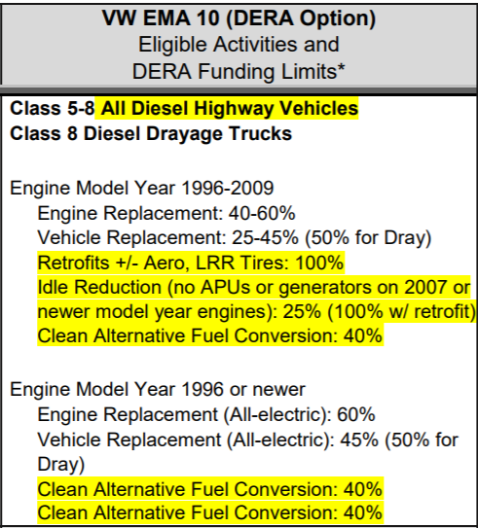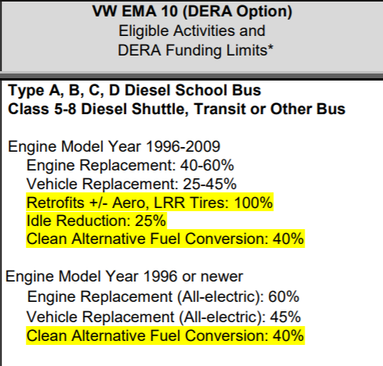

*Project eligibility criteria and applicable funding limits for the DERA Option are subject to change pending final program guidance issued by EPA for the State Clean Diesel Grant Program. The above-summarized criteria come from the FY 2019 State Clean Diesel Grant Program Information Guide.

More information: https://nepis.epa.gov/Exe/ZyPDF.cgi?Dockey=P100WKEY.pdf

###

